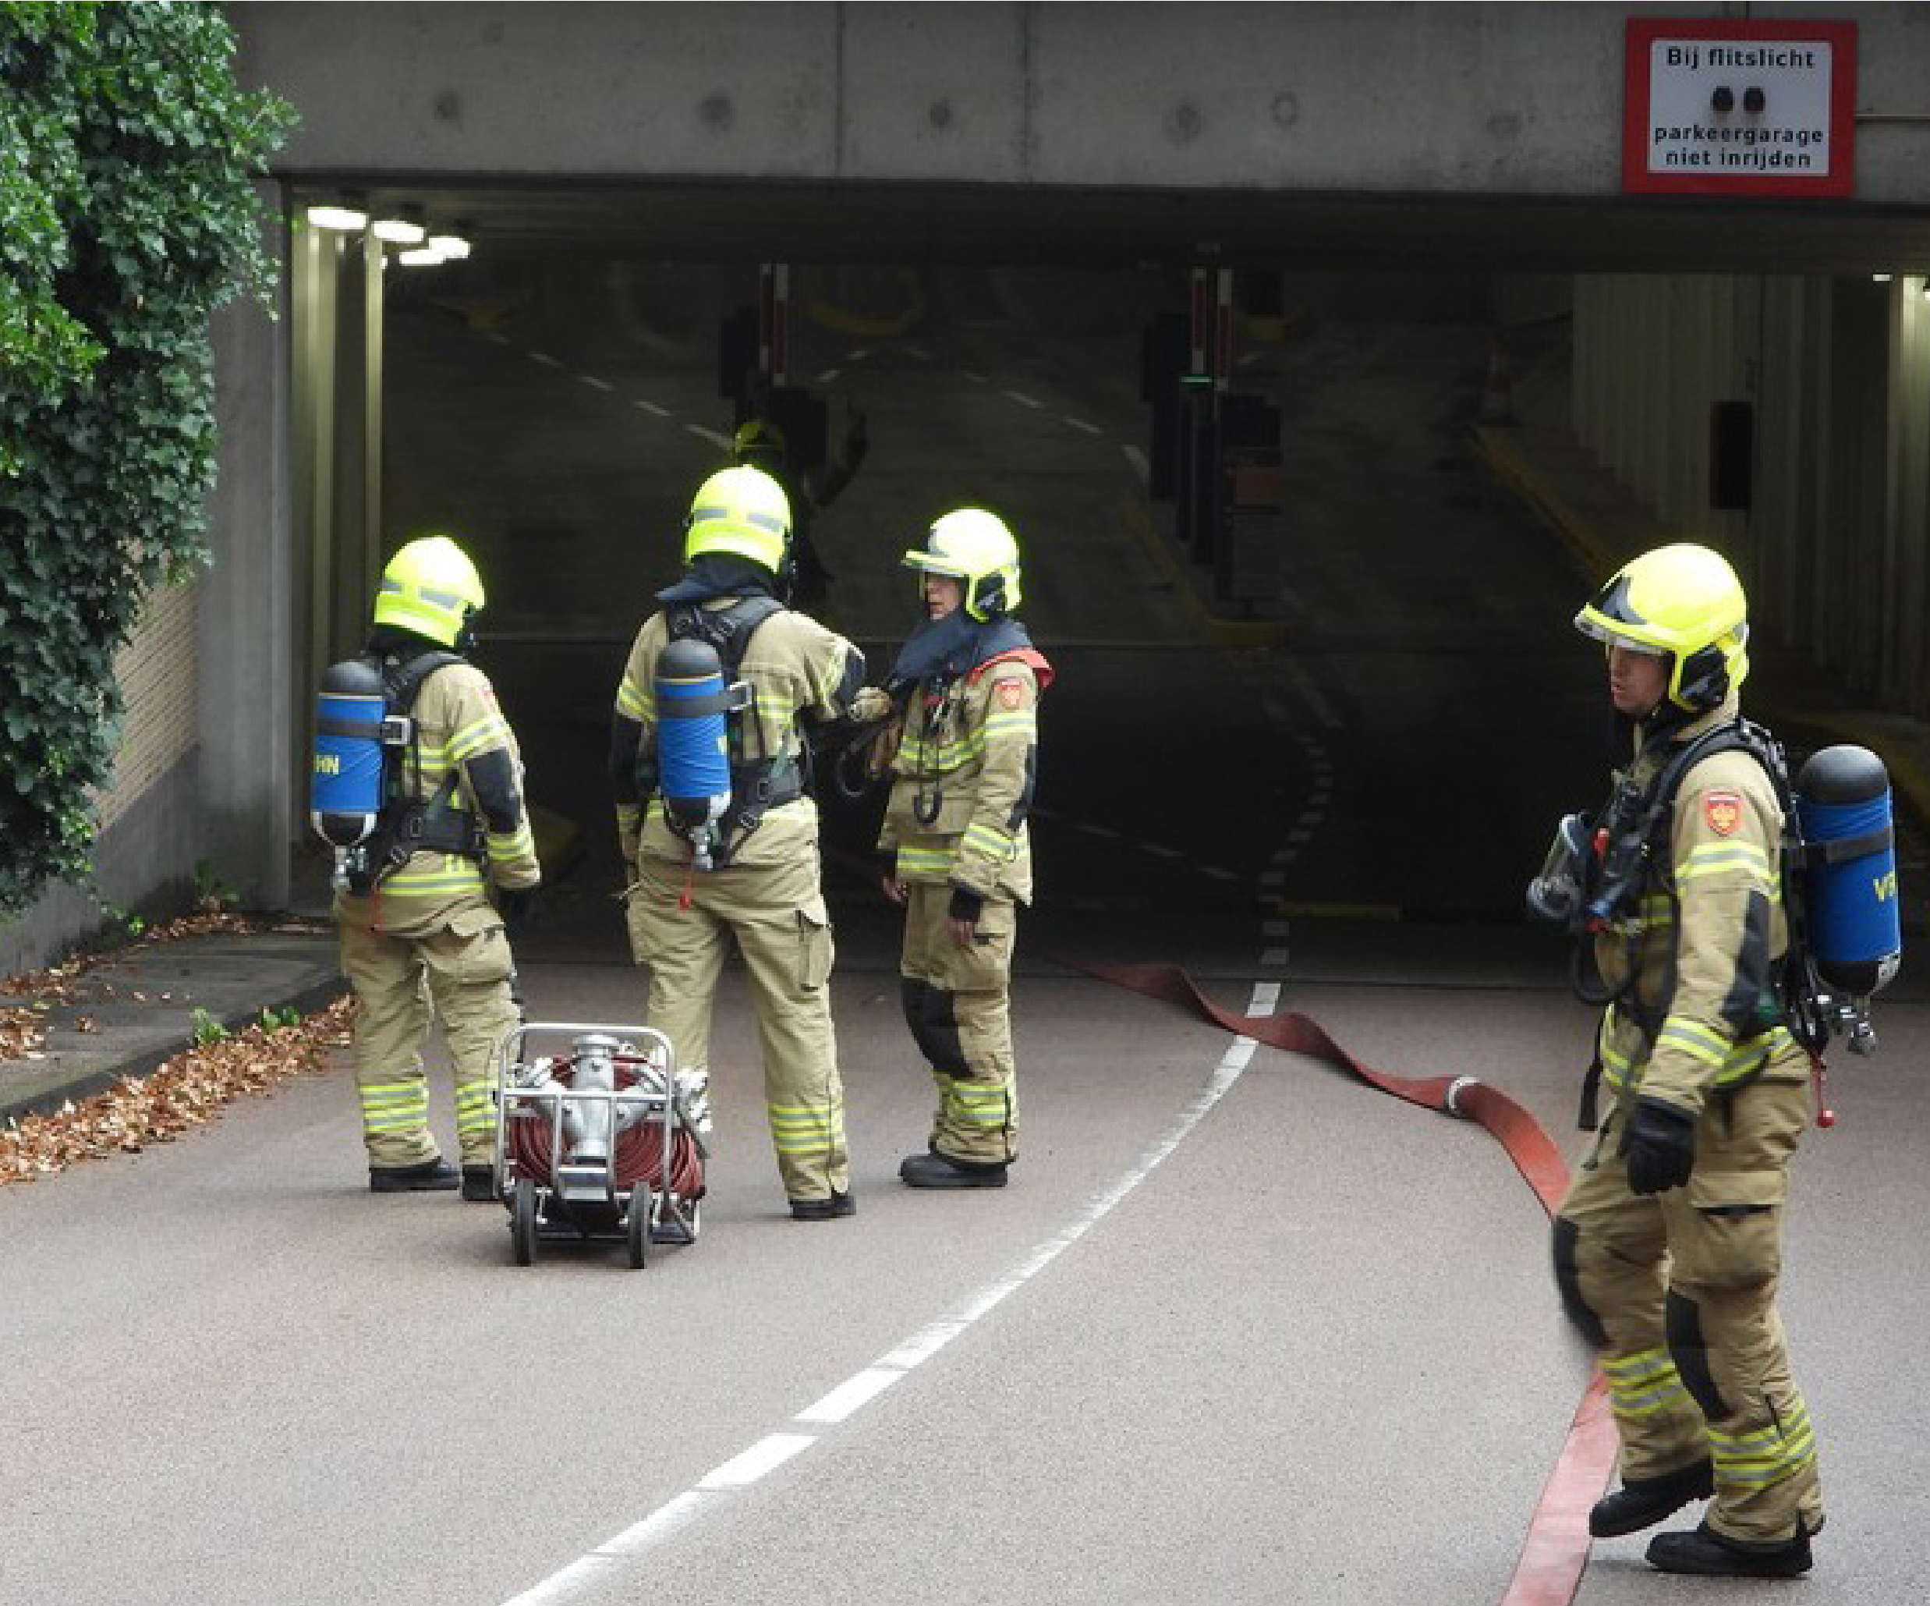
The fire in the Singel garage in Alkmaar
The Fire Academy is part of the Institute for Physical Safety.

Institute for Physical Safety
Brandweeracademie
P.O. Box 7010 6801 HA Arnhem www.ifv.nl info@ifv.nl
026 355 24 00

Colophon

Fire Academy (2020). The fire in the Singel garage in Alkmaar. Arnhem: IFV.

Client: | Institute for Physical Safety
Contact: | dr.ir. N. Rosmuller
Title: | The fire in the Singel garage in Alkmaar
Date: | 21 October 2020
Status: | Definitive
Version: | 1.0
Authors: | T. Hessels MSc and ing. J. Ebus
Project leader: | ing. R. van den Dikkenberg MCDM
Review: | eng. R. Hagen MPA on dr. ir. R. Weewer
Responsible: | dr. and. N. Rosmuller
Omslagfoto: | Hans Peter Olivier and Evelien Olivier-Wittenberg

Foreword
A fire in a parking garage is not a daily occurrence in the Netherlands. Fortunately. Fires in parking garages are extremely difficult to fight by the fire brigade because of the long attack routes and large deployment depths, the poor visibility and thesurrounding logistics, but above all because of the dangerous environment. It is not for nothing that one of the basic principles of the fire brigade in the Netherlands is: first explore from the outside. This is all the more true in fires involving electric vehicles. Electricvehicles have a different fire course than conventional vehicles: slower and longer.

And how beautiful it is to study the (most likely lit) fire of two vehicles (one of which is electric) on parking layer -2 in De Singelgarage in Alkmaar (1 July 2020) to learn from it. And as this learning process has shown again: learning is something you do together. In this case, these are: us from the IFV, TBO-ers from the VRNHN, the municipality of Alkmaar, other safety authorities involved, the police, the dealer organization of the vehicles and the recovery company involved.

It is no longer the case, and certainly not in the context of the energy transition, that one party has all the (safety) wisdom in lease. And you can see that here too. Each personprovides his (partial) expertise to be able to understand and learn from the events. But this aspect of in-depth sub-expertise also makes the security aspects of the energy transition vulnerable through fragmented knowledge andresponsibilities and opaque dependencies. A vulnerability of safety that you should not rationalize away with the adage: 'The chance is small, and if it goes wrong, the fire brigade will solve it'. That time has passed. You willhave to properly arrange the risks at the front (risk management), so that the fire brigade at the back is not faced with almost impossible tasks (incident control).

I am therefore very grateful to those who have contributed to the present reportfor contributing their partial expertise. Because of them we are as a country
(fire brigade, parking industry, recovery companies, ...) able to learn about the whole from this kind of – fortunately but rarely occurring – fires.

Nils Rosmuller
Lecturer energy and sportssafety

Contents
List of abbreviations used 6
Introduction 7
1 A global description of the incident 11
1.1 Description of the car park 11
1.2 The fire 12
2 Gebouwkenmerken 14
2.1 Layout of the car park 15
2.2 Escape routes 16
2.3 Preventive measures 17
3 Environmental and human characteristics 20
3.1 Omgevingskenmerken 20
3.2 Menskenmerken 21
4 Brandkenmerken 22
4.1 Brandoorzaak 22
4.2 Brandverloop 23
4.3 Rookverspreiding 27
5 Interventiekenmerken 29
5.1 Alarm 29
5.2 Imaging 30
5.3 Firefighting 31
5.4 Ventilation 32
5.5 Nafase 33
6 The use of robots 34
6.1 The extinguishing robots of the Amsterdam-Amstelland Fire Brigade and the Haaglanden Fire Brigade 34
6.2 The transport robot of Police Unit The Hague 35
7 Answers to the research questions 36
7.1 What was the fire course like? 36th
7.2 How did the fire brigade action go? 36th
7.3 How did the use of robots work in combating the inci dent? 37th
7.4 What was the involvement of (the battery pack of) the electric car in the fire? 38th
7.5 What were the fire prevention facilities present? 38th
8 Interpretation 40
8.1 Advance 40
8.2 Important aspects of this fire 40
8.3 Application of the basic principles of firefighting 41
8.4 The influence of the presence of an electric vehicle 42
8.5 Looking at the whole 42
Literature 44
Annex 1 Timeline 45
Annex 2 Overview of the units concerned 50
Annex 3 Articles from the Building Decree 1992 51
Appendix 4 Examination of the battery pack of the Hyundai Ioniq 53
Annex 5 The questions of the Working Group on Security of the National Agenda
Laadinfrastructuur 63
Appendix 6 Inspection process and responses 66

List of abbreviations used
100 First Officer of Service

200 Second Officer of Service
300 Third Officer of Service

AC Alarm Centre
AGS Hazardous Substances Advisor

CO Carbon Monoxide

GMS Integrated Control Room System
GRIP Coordinated Regional Incident Response Procedure

HW Aerial Platform

LCOPI Leader Command Place Incident
LD Low Pressure

NB Further Notice

OC Operational Centre
OvD Officer of Service
OvDB Officer of Fire Service
OvDP Officer of Police Service

Prio1 Priority 1, with optical and acoustic signals

RVO Netherlands Enterprise Agency

SBH Schuimblushaakarmbak

TC Taakcommandant
TS Tankautospuit

WBC Warmtebeeldcamera
WBDBO Resistance to fire penetration and fire transfer

ZGB Very Large Fire

Introduction
On Wednesday morning, July 1, 2020, a fire raged in the Singel garage in Alkmaar. In the underground car park – consisting of two parking layers and offering space for 396 cars –a car was on fire in two different places on parking layer -2. The police have arrested someone suspected of arson. During the fire, 153 vehicles were parked in the parking garage. One of the two passenger cars involved in the fire was ahighly electric Hyundai Ioniq which was not at a charging station. The burning vehicles were about 50 meters apart. No other vehicles were parked between the two vehicles. A largenumber of fire brigade units from five regions have been deployed in the firefighting, including two extinguishing robots from the Amsterdam-Amstelland and Haaglanden fire brigades.

The burnt-out Hyundai was removed from the parking garage with the help of a robot from the Haaglanden police. The auto was, because of the involvement of the car's battery pack in the fire, then placed in a submersible container of the vreugdenhil company and disposed of.
Purpose of the study
Fires in parking garages are complex incidents. At the beginning of 2020, politicians and the media repeatedly paid attention to the risks of fires in parking garages, in particular when electric vehicles are parked in them. However, it has not often happened in the Netherlands that a fully electricvehicle has burned out in a parking garage, making the incident in Alkmaar a case from which to learn. That is why the Institute for Physical Safety (IFV) and the NoordHolland-Noord Safety Region (VRNHN) have jointly conducted an investigation intothis fire and the fire brigade's actions.

The present report was drawn up after a relatively short investigation. Due to the rapidly developing market of electric cars and charging infrastructure and the great need for clarity about this fire and the fire brigade action, we want to learn lessons quickly where possible. The investigation report provides a description of the fire and the associated fire brigade action. On the basis of the (limited) available documents, information is alsogiven in the fire prevention facilities in the parking garage. However, an opinion on these provisions is beyond the purpose of this limited investigation.

Research questions
Based on the needs of the IFV, the VRNHN and the safety working group of the
The National Charging Infrastructure Agenda of the Netherlands Enterprise Agency (RVO) has drawn up five (main) research questions that have been leading for thisresearch:
1: How was the fire course?
2: How did the fire brigade action go?
3: How did the use of robots in combating the incident go?
4: What was the involvement of (the battery pack of) the electric car in the fire? 5: What were the fire prevention facilities present?
Research method
The information on which this report is based has been collected in a variety of ways. On Wednesday 1 July and the day after the fire, Thursday 2 July, the VrnHN Fire Investigation Team (TBO) conducted an investigation in the parking garage. On Thursday, a researcher from the IFV looked at this study, in which an attempt was made to reconstruct the smoke spread and the fire course. The situation and the damage image in the parking garage have been recorded on photos by the TBO as much as possible. In addition, on Wednesday 8 July, a fire researcher from the IFV, together with a specialist from Hyundai and fire researchers from the VRNHN, investigated the battery pack of the burned-out Hyundai Ioniq. The battery pack was disassembled and examined at Hyundai's research centre. All findings have been photographed.

In order to get an idea of the fire prevention facilities, the building permit for the parking garagewas requested. In addition, the Risk Management department of the VRNHN provided information.

In order to gain insight into the repressive actions of the fire brigade, researchers from the IFV participated in several (digital and physical) learningevents of the VRNHN. At these meetings the commanders, officers on duty, the task commander and the control room centralists, as well as the persons who were part of the special fire brigade units such as firefighting robots and the container special extinguishing agents were present. Where necessary, individual interviews were held by the IFV after these meetings in order to obtain additional information. Information was also extracted from notepad data, status times and individual incident reports. Finally, the municipality of Alkmaar was given the opportunity to respond to factual inaccuracies in the draft version of the final report. For the sake of transparency and to confirm the objectivity of the IFV, that response and the justification with regard to its processing is explicitly included in Annex 6.

For the further analysis and structure of the report, use is made of the characteristic scheme as found in the publication Basis voor Brandveiligheid
(Institute for Physical Safety, 2017). See figure I.1 on the next page.

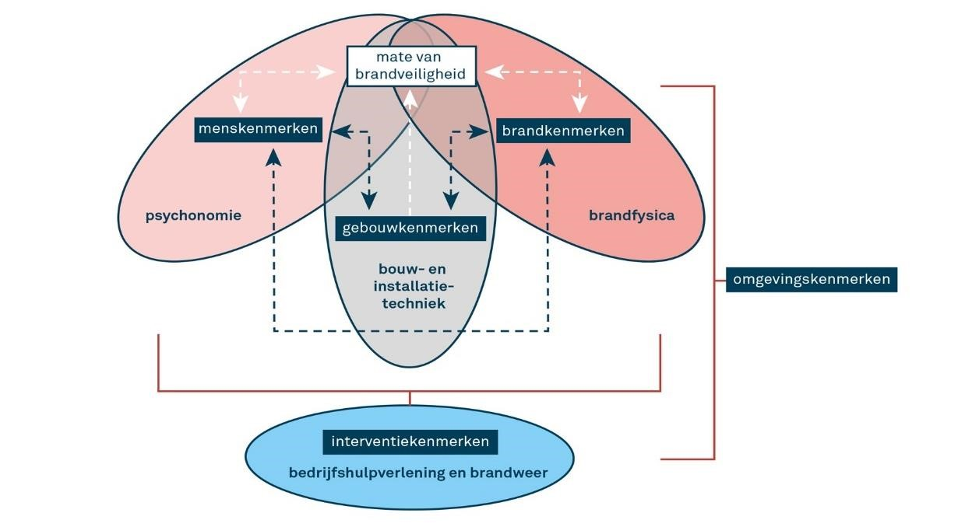

Figure I.1 The attribute scheme
The characteristics scheme is an analysis and assessment system that assumes that different characteristics determine how a fire develops and how the consequences of this fire can be explained. The assessmentis based on:
> | building characteristics: the building design (architecture, structural engineering and fire prevention)
> | fire characteristics: the typical (fire physics) characteristics of the fire
> | environmental characteristics: the (physical) environmental factors.
> | human characteristics: the behaviour of people
> | intervention characteristics: the (internal and external) assistance in the event of a fire

The value of applying the characteristic scheme is that the various factors can be investigated in a systematic way. It also offers an integral consideration of the incident, since a wide range of factors are mentioned fromdifferent disciplines, such as engineering (building characteristics), planning (environmental characteristics), physics (fire characteristics), psychonomy (human characteristics) and fire science (intervention characteristics).
Reading guide
In the first chapter of this report, thecourse of the incident is described by means of a timeline of developments. The various building, fire, environmental, human and intervention characteristics are described in the following chapters 2 to 5. Not every element of the characteristic sc hemaweighs equally in an incident. In this fire, two characteristics – the environmental and human factors – played a limited role. Therefore, these characteristics are named in one chapter. Chapter 6 deals with the use of robots during the incident. In the last two chapters of this report, an answer is given to the research questions asked and an explanation is given to the findings made.

1 A global description of the incident

1.1 Description of the car park
Parking garage De Singel is located on the southwest side of the center of Alkmaar. The parking garage was completed in 1998 and is for the most part located under the Singelgracht. The situation is shown schematically in Figure 1.1. The parking garage consists of two underground parking layers that can be reached via the entrance for passenger cars on the Metiusgracht / Wilhelminalaan. An intermediate plateau is reached via a ramp, from where you can drive to parking layer at -1 or -2 (see
Figure 1.2 on the next page). The Singel garage can accommodate 396 cars and has six charging points for electric vehicles on parking layer -2.
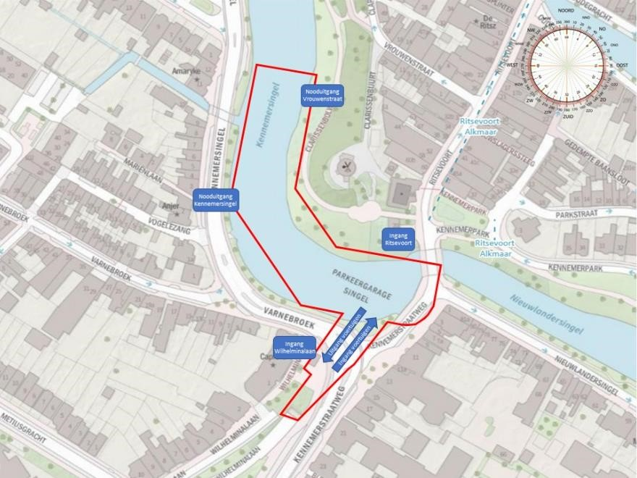

Figure 1.1 Location of the parking garage

There are two entrances and exits for visitors. Entrance 'Singelgarage MCA' at the
Wilhelminalaan and the main entrance 'Singelgarage centrum' on the Ritsevoort. In addition to the two regular entrances and exits, there are two more emergency exits (Kennemersingel and Vrouwenstraat). The parkeergarage is open 24 hours a day, 7 days a week.

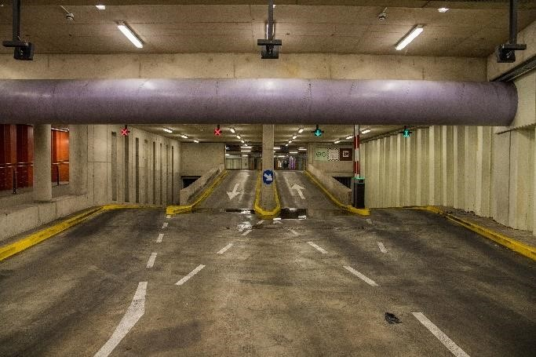
Figure 1.2 The intermediate plateau

1.2 The fire
Probably caused by arson, breaks in the early morning of Wednesday
1 July fires out in De Singelgarage. Two passenger cars, parked on parking layer -2 at about fifty meters distance from each other, catch fire. At 06:21 the First Report of this fire arrives at the Control Room Noord-Holland. This concerns a 112 notification from Valet Parking Service. The employees of Valet Parking see on the camera images that a fire has broken out in the garage. They report that there are 153 cars inside, but cannot see exactly where the burning cars are located. There are also two reports of bystanders, who see smoke coming from the ventilation duct of the parking garage.

Shortly after his arrival, the commander of the first tanker sprayer (TS) scales up to 'big bran d' based on what he finds. After this upscaling, the Officer of Service (OvD) (100) who is still approaching asks for a second OvD, scales up to 'very large fire' a little later and announces GRIP1. Later, around 07:16, the Task Commander requests a second 'platoon fire'.

In the initial phase of the incident, several reconnaissance attempts are made by the first arriving vehicles. No heat is detected by the units on parking layer -2. During these reconnaissances, the vehicles involved in the fire are not yet found. Due to the very limited visibility and the explosions heard, the reconnaissance attempts are stopped, after which the units withdraw. After this, the Parking Service shows video images showing the origin of the fire. A new, targeted reconnaissance attempt is then made. The Task Commander and the 100 will coordinate around 08:00, in consultation with the teams, to arrive at a go / no-go moment for a final reconnaissance attempt to find the firehaard, after which it will be withdrawn if it is not found. The various units are given until half past 9 to explore in the parking garage. During this reconnaissance attempt, both burning vehicles are found and extinguished.

After extinguishing both vehicle fires, the extinguishing robot, among other things,
from the Haaglanden safety region and the fans from the Special Extinguishing Agents container of the Amsterdam-Amstelland safety region, the parking garage wascleared of smoke. After it is determined that the battery of the electric car is still warm and people are afraid of instability of the battery pack, it is decided to remove the car from the parking garage. This is done with a robot of the police, after which the car isremoved in a submersible container.

Appendix 1 contains an extensive timeline of the course of the fire. In Image
1.3 the location of both burning passenger cars in the parking garage is shown schematically.
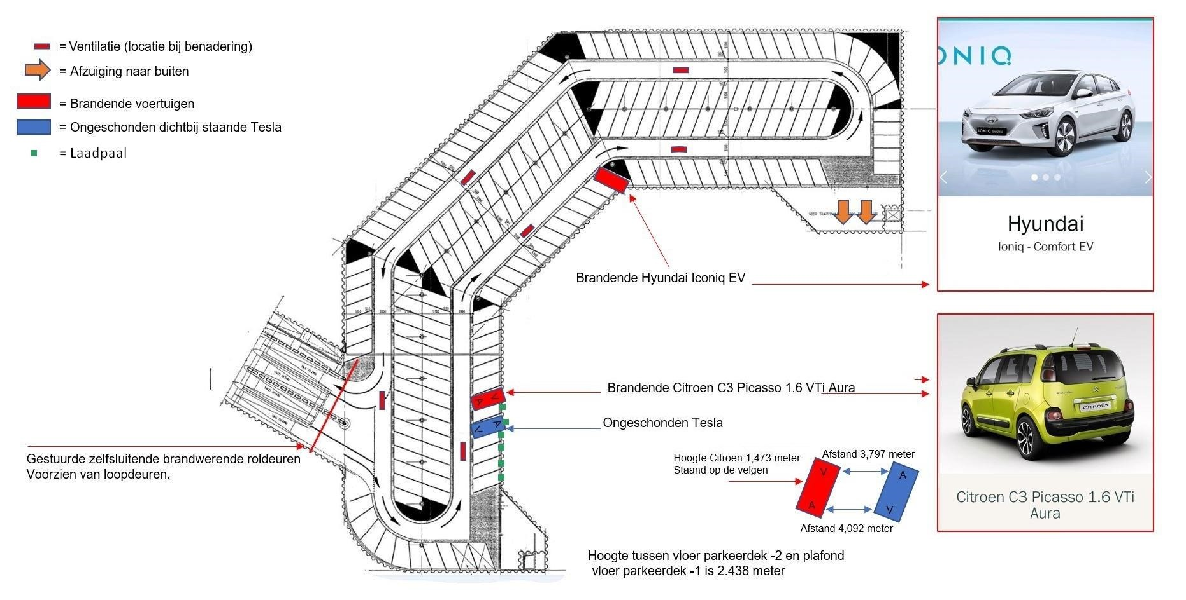
Figure 1.3 Schematic representation of the location of the burning vehicles

2 Gebouwkenmerken
The building characteristics relevant to this research are the location, layout, the fire prevention facilities such as fire and smoke compartmentation and theedge protection installations. The building characteristics have a direct influence on the fire characteristics and the possible flight behaviour and the flight possibilities of people (the human characteristics, see the next chapter).
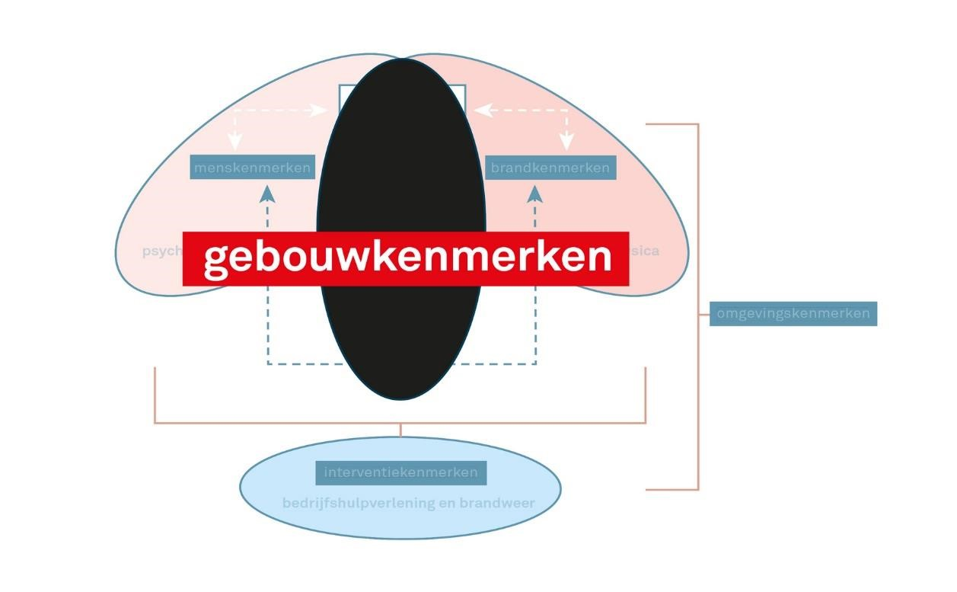
Figure 2.1 Building characteristics
As mentioned, the (public) parking garage De Singel was built in 1998. The building has two underground parking decks, namely parking layers -1 and -2. The parking garage can accommodate 396 vehicles. On parking layer -2, next to the entrance at the Ritsevoort, six charging points are located for electric vehicles. The parking garage (floors, ceilings and columns) is built of concrete, has a flat ceiling and has two staircases for visitors: the main entrance on the Ritsevoort and an entrance on the Wilhelminastraat. In the event of a fire alarm, the stairwell at the Ritsevoort will be under overpressure. In addition to the two stairwells for visitors, there are two escape stairwells: one on the Vrouwenstraat and one on the Kennemersingel.

The documents made available state that the concrete columns and steel beams in the parking garage must be fire-resistant for 60 minutes. It is not indicated on the drawing what the fire resistance requirement of the fire-resistant sliding doors is. Thestairwells are equipped with a fire resistance of 30 minutes. At that time (1998) a fire resistance of 30 minutes towards the stairwell and then 30 minutes fire resistance from the stairwell to the next fire compartment was assumed. Samen a fire resistance of 60 minutes. This together with the fire resistance requirements for the columns and beams is an indication that the fire resistance between the fire compartments is 60 minutes.
No information has been received about possible subsequent adjustments to the installations, such as the fire alarm system, the ventilation system, etcetera.

2.1 Layout of the parking garage
The shape of the parking garage is in line with the shape of the canal under which it is located. The total usable area of the parking garage is 8,766 m² (4,383 m² per floor). The layout of the parking garage is shown schematically in Figure 2.22.2.

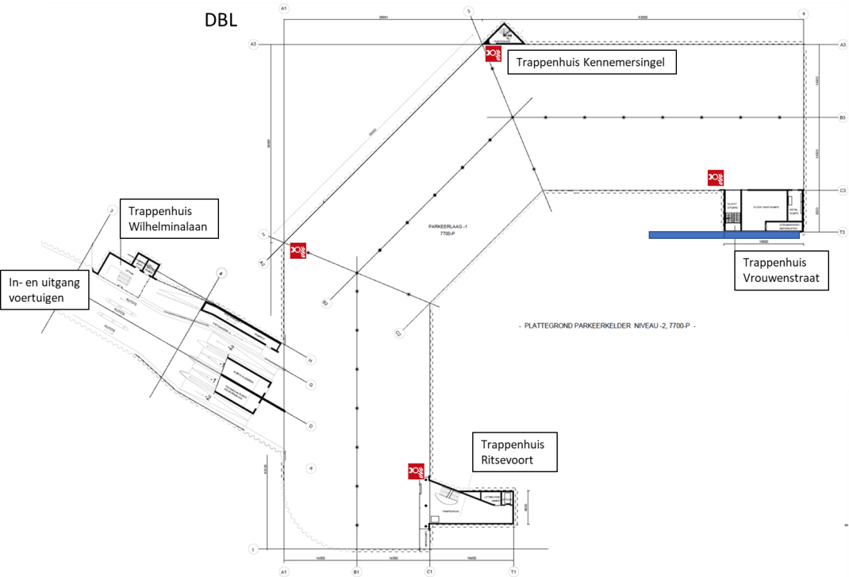

Figure 2.2 Layout of the parking garage
Figure 2.3 below shows an image of the exit of the parking garage, seen from parking layer -1.

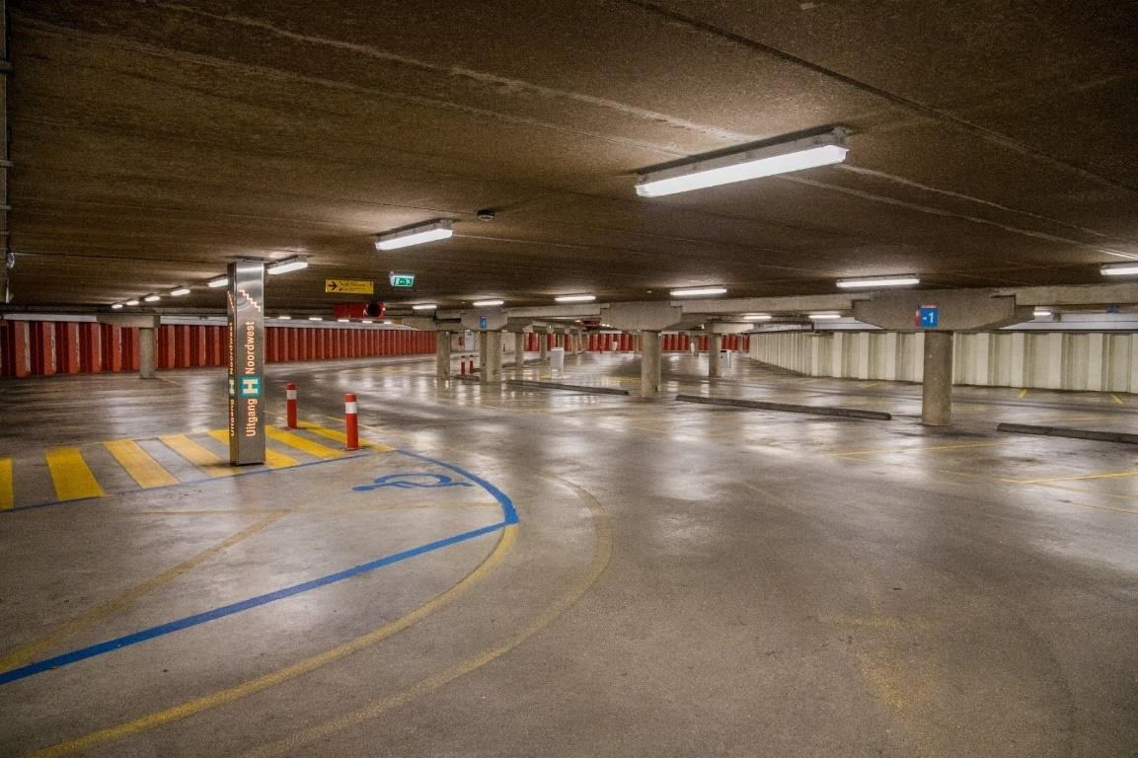

Figure 2.3 View of the parking layer -1 from the exit

2.2 Escape routes
The parking garage has escape route indication and, as already mentioned, has two escape stairwells, one of which opens onto the Kennemersingel and another onto the Vrouwenstraat. From both -2 and -1 you can flee upwards. Thestairwells are closed on the surface by means of a hatch that can be opened to the outside. At the time of the fire, these shutters were closed. At a later stage of the deployment, the stairwells were opened from the inside by the fire brigade to make a deployment from these stairwells. The shutters cannot be opened from the outside. Both emergency exits are shown in Figure 2.42.4 and Figure 2.5.
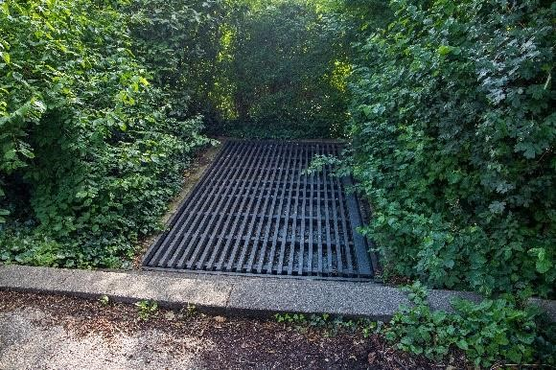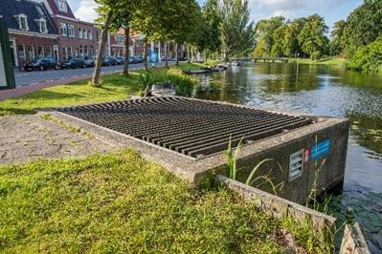

Image 2.4 Emergency exit at the Figure 2.5 Emergency exit at the Kennemersingel Vrouwenstraat

The entrance doors of the stairwells are automatically unlocked after a fire alarm or can be unlocked by pressing a hand detector. From these stairwells, the adjacent terrain can only be reached if the hatch on the sideof the stairwell is opened. The hatch is unlocked in the event of a fire alarm and can be opened from the inside. It is not possible to open these shutters from the outside to enter the parking garage.

2.3 Preventive measures
In this paragraven the preventive measures are described. Successively, the fire safety provisions, the other facilities and the fire safety plan are discussed.

2.3.1 Brandveiligheidsvoorzieningen

Brandcompartimentering
Each parking layer is designed as a fire compartment, with which each fire compartment
4383 m² in size. By means of fire-resistant sliding doors at the location of the ramps, the parking layers are separated from each other. Between the stairwells and the parkfloor, a separation construction is present on the drawings, which is fire-resistant for 30 minutes. The WBDBO between the compartments is not indicated on the drawings. From the information on the fire resistance of various structural components, it can be concluded that the requirement is most likely 60 minutes.

Brandmeldinstallatie
There is a fire alarm system with a full scope of surveillance, with object monitoring and with notification to the Control Room Noord-Holland. There are multisensor detectors and hand-held fire detectors. After a fire alarm, the access doors to the stairwells, the shutters that give access to the adjacent area, the cabinets containing the portable extinguishing agents, the lifts, the adhesive magnets of the fire-resistant sliding doors, the parking system and the side tableau in the management area are automatically unlocked or controlled.

Ontruimingsalarminstallatie
There is a spoken word evacuation alarm system present.

Dry extinguishing pipe
There is a dry extinguishing pipe. The feeding point of the dry extinguishing pipe is positioned at the main entrance 'Singelgarage centrum' (stairwell Ritsevoort). There are four collection points on each parking layer. Three of these are located next to one of the stairwells. See Figure 2. 6.

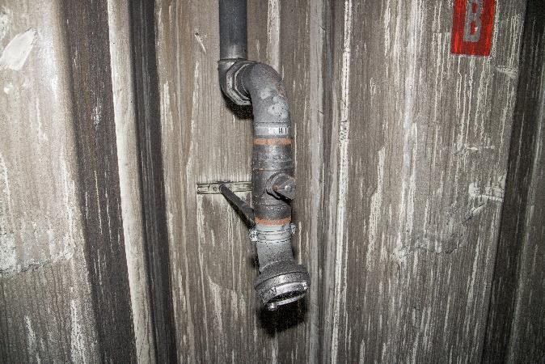

Figure 2.6 Point of collection of the dry extinguishing pipe
Emergency and transparent lighting
The parking garage is equipped with emergency lighting and transparent lighting (an illuminated escape route indication).

Portable extinguishing agents
The hand fire extinguishers are located in a cabinet that is automatically unlocked in the event of a fire alarm or after pressing a hand detector.

Red hand detectors
Red hand detectors have been installed, with which the electronically controlled doors and cabinets canbe unlocked. These are the doors of the escape stairwells and the cabinets containing the portable extinguishers.

2.3.2 Other provisions
The ventilation system
Near the stairwell that opens into the Vrouwenstraat there is a shaft with exhaust fans for the purpose of removing the air from the parking garage. There are twelve stowage fans in the parking garage. According to the annual maintenance report, there are also four overpressure fans in the parking garage. These are as many as there are stairwells that, according to the available documents, would be under overpressure. There are no supply channels for the ventilation system in the parking garage. In normal use (no fire), the fire-resistant sliding doors are open and the entrance and exit function as an air supply supply. After a fire alarm, the doors close automatically, so that the air supply stops. The fans are not equipped with cabling with function retention. From this it can be concluded that the ventilationsystem serves for use ventilation (the supply of clean and discharge of polluted air) and is not installed for ventilation during a fire.

CO and LPG detection
CO and LPG detection is available in the parking garage. When a certain value of CO or LPG is detected, the ventilation system is controlled.

Additional transparencies
In the parking garage there are transparencies with the text 'Leave the engine garage'. A flit light is also placed on the transparencies.

2.3.3 Brandveiligheidsplan
A building permit application for changing the entrances and exits of the parking garage, received by the municipality of Alkmaar on 26-5-1997, shows that advice was given in September 1994 about thepermit. In 1994, the Building Decree 1992 and the Building Regulations adopted by the municipality of Alkmaar applied to the parking garage. The Building Decree 1992 contains functional requirements, of which annex 3 contains some relevant articles.

The documents Building a fire-safe building and Installing a fire-safe building of the Dutch Fire Brigade Federation were used in the 90s to further implement the functional requirements of the Building Decree 1992. The fact that these were also used in advising on the parking garage is evident from the advice of the fire brigade on the building permit application from 1997. In this advice, an overview with the fire protection systems ticks which installations must be present . There is no cross at smoke and heat extraction installations. Figure 2.7 shows table 8 'Parking building', taken from Building a fire-safe building. The booklet 'Installing a fire-safe building' indicates what the installations must comply with.

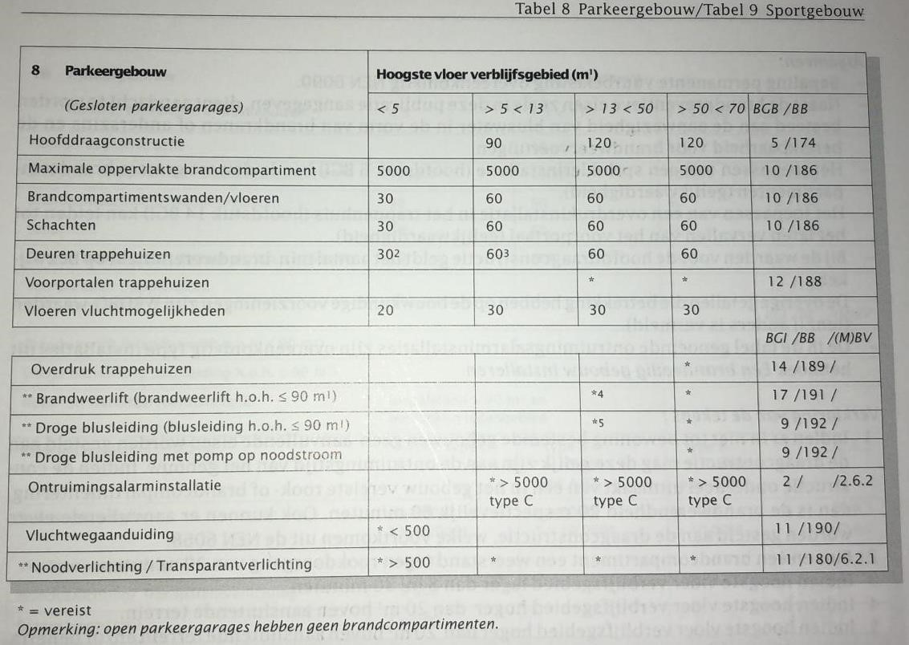
Figure 2.7 Table 8 'Parking building' from Building a fire-safe building, Dutch Fire Brigade Federation

3 Environmental and human characteristics
Because the human and environmental characteristics had only a limited influence on the course of the incident in the Alkmaar parking garage, joint attention is paid to them in this chapter.

3.1 Omgevingskenmerken
The environmental characteristics are about the interactionof the environment with regard to fire safety and incident response.
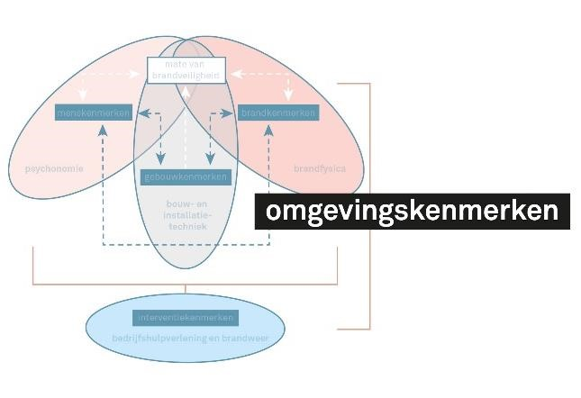

Figure 3.1 Environmental characteristics
The parking garage is largely located under the city canal and the Kennemersingel. As a result, the accessibility of the various (emergency) exits islimited: the fire brigade has to walk around the canal to get to the various exits. This is possible on the south side via the Ritsevoort, on the north side via a bicycle bridge between the Kennemersingel and a park adjacent to the Vrouwenstraat. In Afbeelding 3.2 an aerial photograph of the situation is shown.
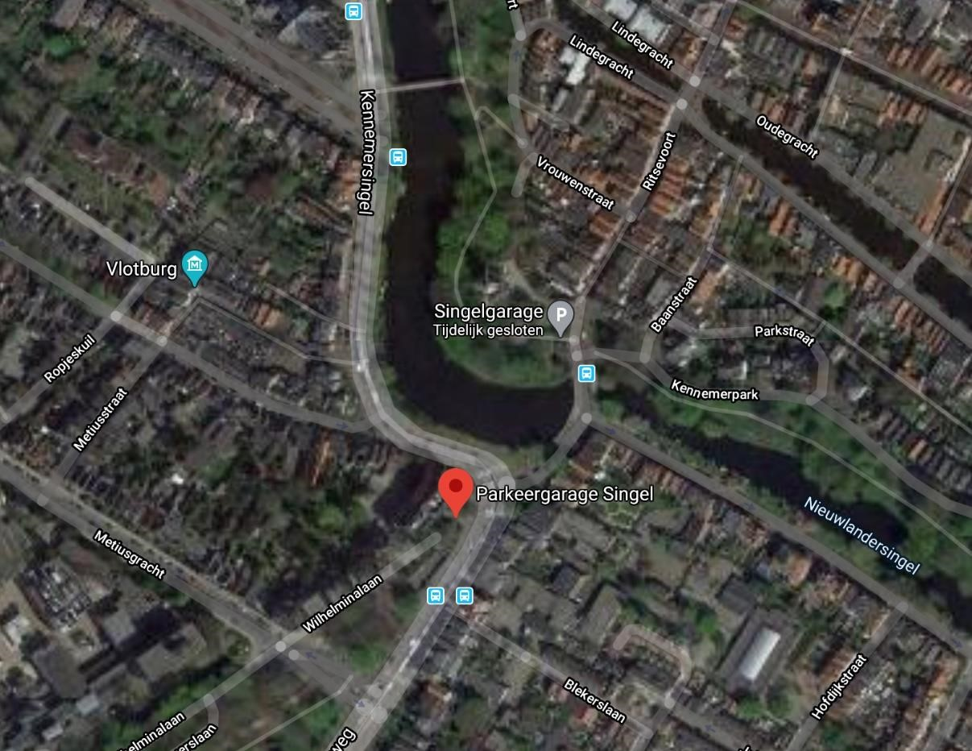

Figure 3.2 Aerial view of the surroundings of the parking garage (source: Google Maps)
Due to the nature and location of the building, the chance of fire spread from the parking garage to other objects or from other objects to the parking garage is nil. The fire brigade deployment therefore does not have to take into account the possibility of fire transfer to other objects. There is also no question of combined building functions, such as a residentialarea above the parking garage, that would entail specific risks.

The location of the parking garage is such that the fire brigade can be on site within the legal standard time of ten minutes. Around the garage are several primary and secondary extinguishing water supplies.

3.2 Menskenmerken
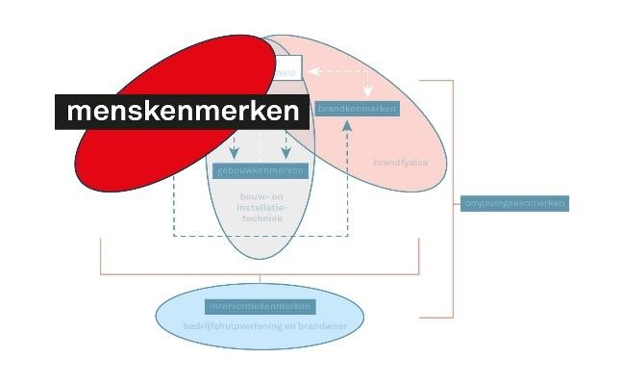
Human characteristics include the behaviour of people in the vicinity of the incident. At the time of the fire, there were two self-reliant people in the garage, who fled in time.
Figure 3.3 Human characteristics

4 Brandkenmerken
This chapter discusses the fire characteristics. Fire characteristics are not only about the origin and course of a fire, but also about heat, smoke and smoke spread. Fire characteristics are closely intertwined with building characteristics and with what is present in the building. The layout of a building and the presence or absence of fire-resistant facilities have an important influence on the fire and smoke development. The fire characteristics, together with the building characteristics, influence the safetyof the people present. Hence the trinity in the characteristic scheme of building characteristics, human characteristics and fire characteristics. In addition to the fire characteristics in themselves, this chapter specifically addresses the course of the fire in relation to the battery of the electric vehicle.
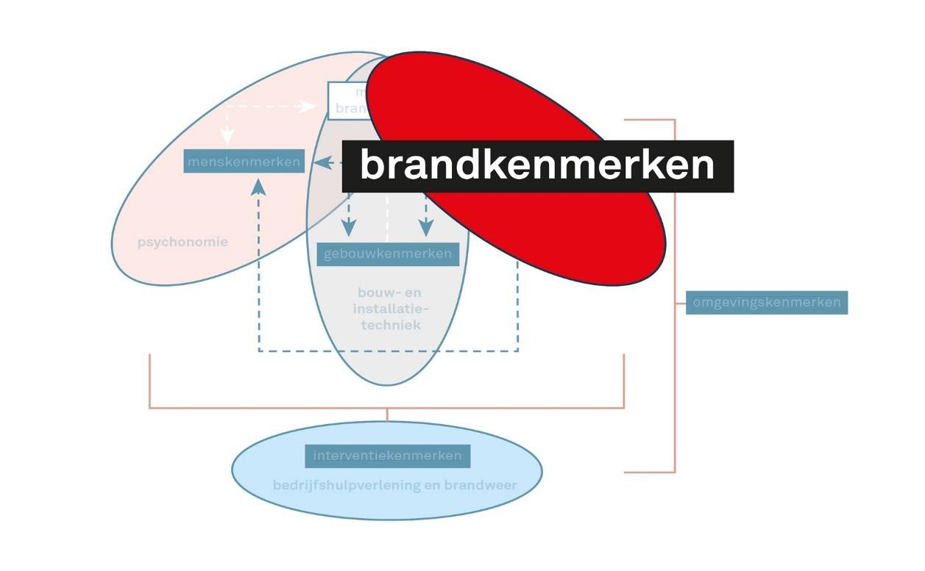
Figure 4.1 Fire characteristics
The Fire Investigation Team of the Noord-Holland-Noord Safety Region investigated the course of fire and the spread of smoke. Sections 4.2 Fire course and
4.3 Smokespread has been established on the basis of the findings of the VRNHN.

4.1 Brandoorzaak
The police have arrested a suspect for the fire in the parking garage. This is an indication that there has been arson, but the cause of the fire is still being investigated by the police and the Public Prosecution Service and is therefore outside the scope of this investigation.

4.2 Brandverloop
In the parking garage, two passenger cars were on fire, which were about 50 meters apart . No vehicles were parked in the parking spaces between the cars. Of the two passenger cars involved in the fire, one was fully electric (Hyundai Ioniq); the other car had a petrol engine (Citroen C3). The Hyundai Ioniq was not at a charging station and was not charged at the time of the start of the fire.

The time at which the vehicles started to burn and the exact course of the fire are not known. There is no log of the fire alarm system of the timeperiod in which the fire started. There are also no video images on the basis of which the starting moment of the fire can be determined. The part of the log that is available shows that the fire alarm system does not receive an answer fromdifferent installation components on the two parking layers. There is a photo of the digital log of the parking garage ventilation (see Figure 4.2). However, the time in the system is not correct, so that the time on the screen must be added to about two hours ; the exact time difference is not known. On the photo of the digital log it is visible that around 06:26 a fire alarm comes from parking layer -1, while shortly before a CO report came in from parking layer -2. In the log there are no reportsfrom parking layer -2. Which controls (possibly) follow the arrival of a fire alarm in the system of the parking garage ventilation is not known to the IFV.

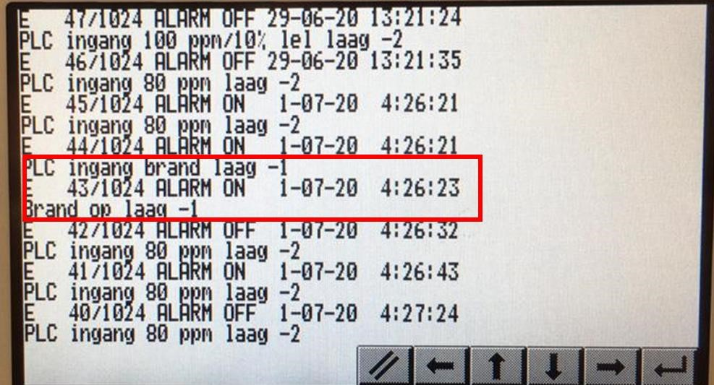

Figure 4.2 Display of the digital log of the ventilation of the parking garage; the times in ventilation panel do not correspond to the actual time
The moment the surveillance cameras showed that a vehicle was on fire, the Parkeerservice called 112. No automatic fire alarm has been received at the North Holland Control Room. Both vehicles are almost completely burned out. In the immediate vicinity of the vehicles, a limited amount of flammable material was present, such as lighting fixtures, a charging station, et cetera. The building itself did not burn, but there is damage to the concrete structure: the fire caused holes in the ceiling above the vehicles. When the stormhad reached the burning vehicles, only a few small flames were visible.

About 4 meters away from the Citroen was, with one free parking space in between, a fully electric vehicle (Tesla). This vehicle was parked in aparking lot for electric vehicles and was connected to the charging station. The vehicle has not burned, has not been affected by heat radiation and has only suffered soot damage (see Image). The hood of the lighting fixture above the Tesla on the ceiling has melted and fallen to the ground. Most such caps are made of polycarbonate and begin to deform at temperatures above 180 ⁰C.

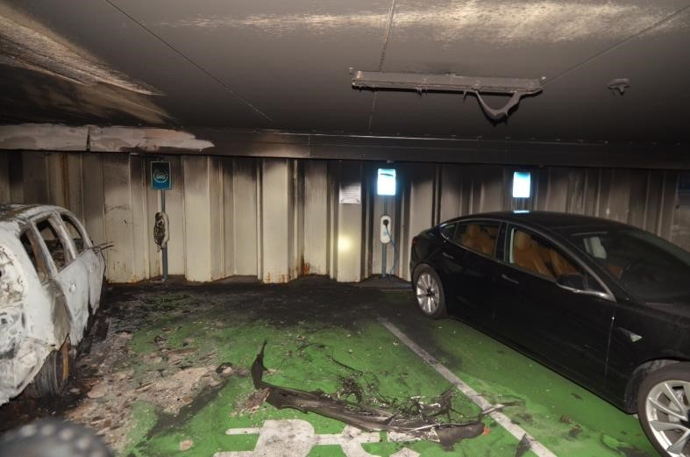

Image 4.3 Tesla next to the burnt-out Citroen C3
On the basis of the information availableto us, we cannot make a statement about the exact course of the fire. The IFV has also not been able to find out why the Tesla has not suffered any damage. The interviews have shown that the Tesla has not been cooled by the fire brigade.

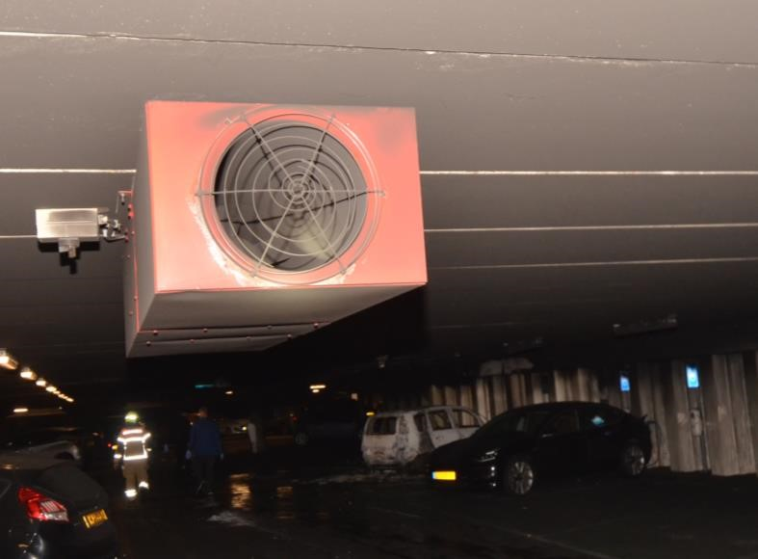

Figure 4.4 Ventilation system in the Singel garage
The ventilation system (see Figure 4.4) is made for use ventilation and is controlled by the CO and LPG detection. During a car fire, CO is produced. The log of the CO andn LPG detection shows that CO is measured in the parking garage from 06:22:48. The first measurement shows 80 ppm and later reaches a maximum of 200 ppm. In the normal situation, these values would drive the use ventilation. The limit values of theventilation system are not known to the IFV.

4.2.1 The contribution of the electric passenger car to the fire
Both the fully electric vehicle and the vehicle with the petrol engine are completely burnt out. The report Fire safety of motorvehicles with electrically driven vehicles (Institute for Physical Safety, 2020) shows that the fire capacity of an electric vehicle is comparable to that of a conventionally powered vehicle. The literature shows that a fire in an electrically powered vehicle develops more slowly, but can also flare up again and again after hours (Sun, Bisschop, Niu, & Huang, 2020). It is not known how the exact fire course in the electric vehicle has been. When a ploughhad reached the vehicle, only a few flames were still visible, which were extinguished. At a later time, some flames were again visible in the trunk of the vehicle.

The ceiling/floor construction above the electric vehicle (Figure 4.5 left) and above the conventionally powered vehicle (Figure 4.5 on the right) was affected by the fire. It is visible that above the conventionally driven vehicle a larger diepte concrete has fallen away, so that more reinforcement of the concrete is visible compared to the concrete above the electric vehicle. This can possibly be explained by the fact that a water jet has been placed on the structure. This can be seen in the cleanrinsed parts of the ceiling and the imprints of the drops on the soot. This may have led to rapid cooling of the concrete, resulting in splashing.

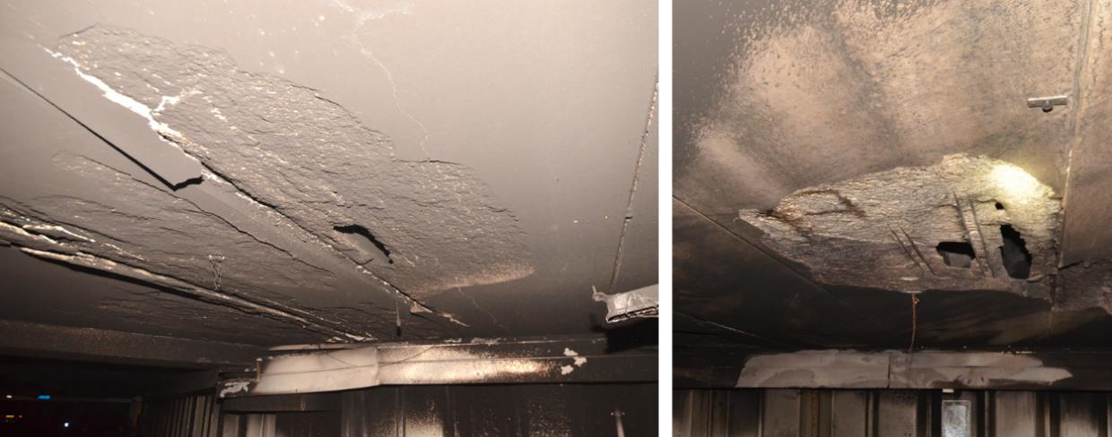

Figure 4.5 Left ceiling construction above the electric vehicle, right above thenon-commercial vehicle
Above the electric vehicle, there is damage to the ceiling structure over a greater length than above the conventional vehicle. A possible explanation for this is that a fire in an electric vehicle lasts longer than in a conventional vehicle. The concrete structure above the electric vehicle may therefore be exposed to high temperatures for a longer period of time. Another possible explanation is that higher temperatures have been reached above the electric car, because the battery pack has become involved in the fire. Two of the battery pack vents open into the vehicle's trunk; around these openings the metal is burned clean. Above these openings there is no metal, such as a roof, that provides shielding between the flames and the concrete structure. Thermal runaways in a battery pack can cause flames with a temperature of up to 1500 ⁰C (Huang, Wang, Li, Ping, & Sun, 2015). If these flames came out of the vents, this may have caused a higher temperature load on the concrete than the flames from the fire in the conventional vehicle. The location of these (ventilation) openings are shown in Figure 4.6.

The exact cause of the difference in damage to theconstruction is not known.

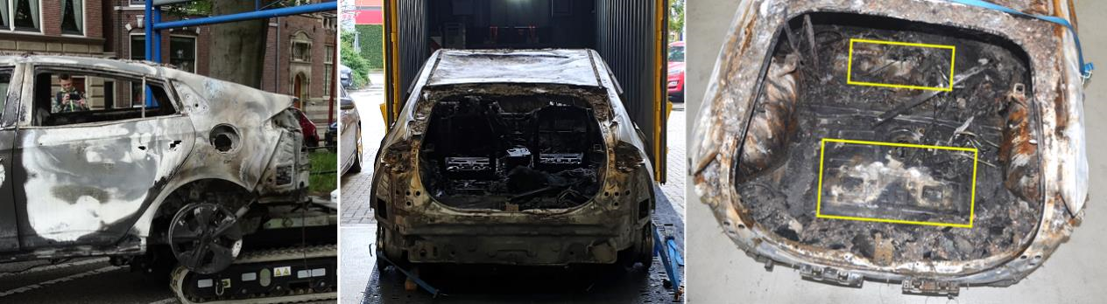

Figure 4.6 Rear of the electric vehicle concerned and the positions of the openings
The battery pack was further investigated in collaboration with Hyundai Netherlands, partly to determine to what extent the batterypack was involved in the fire and whether there were additional risks due to the battery pack becoming involved in the fire. This will be discussed in more detail in the next section.

4.2.2 Battery pack testing
The battery pack appears to have been fully involved in the fire and is completely burned out. It was already known that the fire did not start in the battery pack. Indicators are visible in and on the battery pack that indicate that theremay have been evidence of a 'cutting torch' effect as a result of the thermal runaways in the pouch cells (Li et al., 2020). Such an effect can cause a flame with a temperature of up to 1500 ⁰C, which burns through the metal under high pressure. This mayrelease molten hot metal particles. In a full-scale practical experiment, these effects are
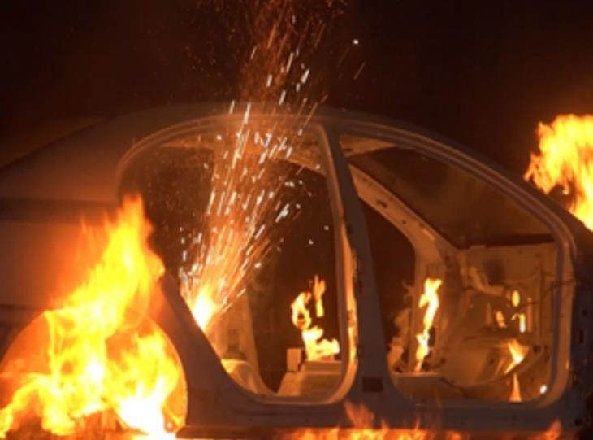
Image

4.7

Cutting torch effect. Source:
(
Li et al.,
2020
)

observed (Li et al., 2020). This can be seen in Figure 4.7 as a shower of sparks spraying upwards. This can be a risk to repressive staff.
However, it should be noted that in the practical experiment the interior was removed from the vehicle, whilethe interior may be able to limit the effect outside a vehicle. Whether the cutting torch effect actually took place cannot be determined with certainty.

Appendix 4 contains the results of the research on the Hyundai Ioniq battery pack.

4.3 Rookverspreiding
Upon arrival at the parking garage, the fire brigade saw black smoke coming from the ventilation shaft at the Vrouwenstraat. In the stairwell at the Ritsevoort there was light smoke. On parking layer -1 no smoke washeard, while on -2 there was a lot of, very dense, black smoke. With the thermal imager there was no view. This may have been caused by many soot particles in the smoke, which reflect the signals from the thermal imager. It is known that an autobedge produces a lot of smoke with soot.

The team that carried out the reconnaissance from the fire-resistant sliding doors on the side of the Wilhelminalaan also found that no smoke was visible on parking layer -1 and that there was smoke on -2from the ceiling to just below knee height (= approximately 40 cm). In the experience of the firefighters, it was 'not hot' on parking layer 2. The commander standing outside the vent's exhaust shaft observed that there was no pressure behind the smoke, but that the smoke was calmly flowing out of the vent. The fans did not seem to be on, where earlier trips to the parking garage clearly showed that the fans were switched on.

Why little to no warmth has been felt in the parking garage
Without cars in it, there is more than 11,000 m³ of air on each parking layer. An explanation for the fact that the fire brigade units deployed hardly felt any heat could bethat the energy from the burning vehicles flowed up with the smoke and hit the ceiling. The concrete above the vehicles could have been damaged as a result, while some of the energy was absorbed by thetower structure. The remaining energy could have been in the layer of smoke that moved away from the vehicles and mixed up. The available fans may also have played a role in this. Together, these factors may have causedthe temperature at the height of people in the smoke layer to be relatively low, while the smoke layer near the vehicles or on the ceiling may have been (considerably) warmer.

The functioning of the mechanical ventilation in relation to the smoke spread The available documents about the construction of the parking garage and its maintenance show that the ventilation was installed as a use ventilation. According to the units deployed, the ventilation system of the parking garage was on the 'automatic' position. Thedocuments have not shown that the ventilation system is designed to ventilate the smoke in the event of a fire. After the fire, it was found that some fans no longer worked. Whether this is a result of the fire or whether they did not work before is not known. If the fans have functioned, they have contributed to the mixing of the smoke.

The fire-resistant sliding doors were closed when the fire brigade arrived. This has cut off the supply of fresh air via the entrance and exit for auto's. Apart from air leakage through seams and cracks, there was no longer a supply of fresh air, which means that the ventilation system will have been less able to work properly. Later in the incident process, at the direction of the Parking Service, the ventilation systemwas set to 'manual', which improved visibility. It has not been recorded whether or not a fan has functioned.

Interviews showed that after opening the sliding doors and using fans, there was a visible effect. The use of the fans has ensured smoke spread to the^{1st} floor. It is not known via which routes this smokespread took place.

5 Interventiekenmerken
This chapter describes what the fire brigade has done to fight the fire and limit the consequences of the fire. These are called the intervention characteristics. Chapter 1 already contains a timeline of the overall course of the incident. This chapter goes into more detail about the notification, alarming and upscaling, followed by the imaging, firefighting, ventilation and the after-phase. Annex 2 gives an overview of the position of the units that were involved in the incident.
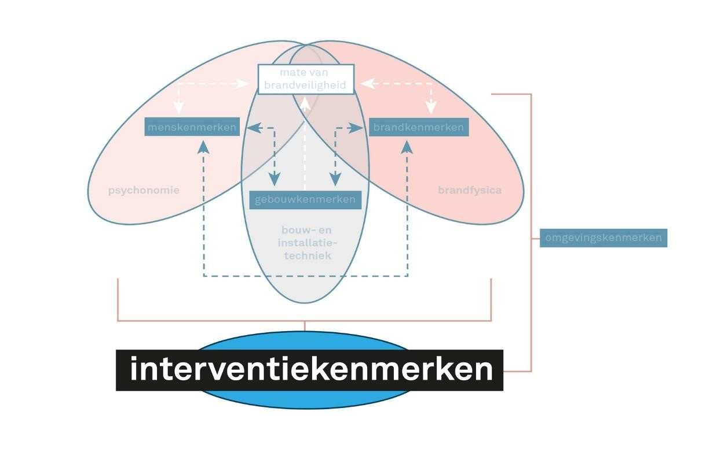
Figure 5.1 Intervention characteristics

5.1 Alerting
At 06:21 the first report of the fire arrives at the joint Control Room Noord-Holland. This concerns a 112 report from Valet Parking, which sees on the camera images that a fire has broken out in the garage. Valet parking reports that there are 153 cars insideand standing, but cannot see exactly where the cars are on fire. There are also two reports of bystanders, who see smoke coming from the ventilation duct.

At 06:23, in accordance with the deployment proposal "Fire Building (other)", two tanker sprayers, a cherry picker and the Officer of Service are alerted (100). At 06:28, five minutes after the first report, the first TS, the TS1 Alkmaar (a TS4) is on site. As a second unit, the HW arrives on site at 06:33, after which the crew of the HW is assembledwith that of the TS4 to arrive at a TS6. The HW is followed at 06:35 by a second TS, the TS2 Alkmaar, and at 06:37 by the OvD.

Shortly after arrival – given the image that the commander of the TS1 Alkmaar finds – the commander ofTS1 Alkmaar scales up to 'large fire'. The 100 is listening in. After the upscaling to 'big fire', he asks for a second OvD (200) and a little later scales up to 'very large fire' and announces GRIP1. Later, at07:16, a second platoon of fire is requested by the Task Commander (TC). The help of an Officer of Service of the Kennemerland Safety Region is also called in, who has been involved in fighting the fire in parking garage De Appelaar.

5.2 Imaging
Driving, the commander of the TS1 Alkmaar sees black smoke coming from the ventilation duct at the Vrouwenstraat. He also sees from the TS that the hatch of the emergency exit on the Kennemersingel is closed. In accordance with the procedure, the first TS drives to the main entrance at the Ritsevoort. There are the key tube, the operation of the technical installation and the main panel. Upon arrival, the first TS is taken care of by the police. The police indicate that there is'light smoke' in the stairwell and 'it would burn downstairs'.

The crew of the first TS then conducts a reconnaissance in the parking garage. At -1, no smoke is observed. At -2, the fire brigade team sees that there is a thick black layer of smoke almost to the ground. During the exploration, it is observed that the automatic sliding doors in the stairwell at -1 and -2 are still working and opening. In the smoke layer at -2, no flow is observed. In the distance, bangs and/or thumps (explosions) are heard by the exploratory team of the TS1. Due to the poor visibility and the observed explosions, the TS1 Alkmaar scales up to
'big fire'.

The plow then returns to the top to apply low pressure. The safetyofficer of the TS1 Alkmaar chooses not to use the dry riser, because he considers it faster to travel directly with low pressure, into the stairwell. When returning to floor -2, the automatic sliding door no longer opens on its own, but must be opened manually. When the team enters the parking garage through the door, it hears banging and thumping in the distance again. Nothing is seen on the thermal imaging camera (WBC) and no heat is felt by the team members. Due to thelimited visibility, the inability to determine the location of the fire and the sounds heard, no further deployment is made at this stage of the incident and the team returns to the top. The door is closed again.

Upon arrival of the second TS (TS2 Alkmaar) there will be consultation with the TS1 Alkmaar. It is agreed that the TS2 Alkmaar goes to the emergency exit at the Kennemersingel to see if the hatch is open or can be opened, in order to be able to deploy from thereand. However, the hatch appears to be closed and cannot be opened from the outside. The TS2 Alkmaar then continues to the Vrouwenstraat. There, too, the hatch is closed. The TS2 Alkmaar then returns to the TS1 Alkmaar, where the 100 has now alsoarrived. After consultation, the TS2 Alkmaar is instructed to do an exploration at -2 with the hoses of the TS1 Alkmaar from the manifold via the stairwell on the Ritsevoort. This happens around 07.30. The information that explosions have been heard is given.
The crew of the TS2 Alkmaar does put a water cannon on the dry riser. She also does a short exploration a small part inside at -2, but still has to deal with thick black smoke. Nothing can be seen via the WBC. Explosions (dull blows) are also observed by the TS2 Alkmaar. Due to the poor visibility and the heard explosions, the crew does not go further into the garage. During the reconnaissance she does not find a burning vehicle and therefore does not use any rays. Er is also not perceived by the teams of the TS2 Alkmaar. The TS2 Alkmaar then retreats and explores the emergency exits of the Kennemersingel and the Vrouwenstraat via -1 to see if there is a view of burning vehicles. Even from thesehours, however, there is virtually no view inside at -2. In both stairwells there is only light smoke. This is headed back to the main entrance to make a further plan.

During the reconnaissance by the TS2 Alkmaar, the TS of Heiloo arrives atthe incident location. The team is taken care of by the 100 and deployed at the entrance on the Wilhelminalaan, together with the 200. The assignment is to explore whether there may still be people present in the garage. The team is exploring the stairwellon wilhelminalaan, which turns out to be free of smoke. From the stairwell she enters the intermediate plateau. There she stands in front of the sliding doors to the entrances of the two floors, which are closed. Through a pass door in the closed hours,the storey floors are explored. At -1 no smoke can be seen, but -2 appears to be full of smoke, which comes to just below the knees. Behind the smoke there is little pressure and initially there is little heat experienced by the men. The parking garage is explored up to about 10 meters. The crew of the TS Heiloo indicates that they have had no visibility.

During the reconnaissance of the TS2 Alkmaar and the TS of Heiloo, the 100 and the TS1 Alkmaar receive additional information from Parkeerservice, which has seen on camera images that two cars have been set on fire. It is not clear at that time whether the fire has spread to several vehicles. It is also indicated that one of the cars that are burning right next to the entrancemust be at -2 from the ritsevoort entrance.

5.3 Firefighting
By the Task Commander and the 100, in consultation with the teams, around
08:00 tuned to arrive at a go/no-go moment for a final reconnaissance attempt to find the firehaard, after which if the fire is not found it is withdrawn. The various units that indicate that they consider it safe to explore further, are given until half past 9 to carry out this reconnaissance in the parking garage. During this attempt atrecognition, both burning vehicles are found and extinguished.

Based on the information from the camera images, it is clear to the TS2 Alkmaar that a car must be on fire right next to the ritsevoort entrance where she travelled. It is used again with a jet of low pressure and the WBC. The first burning car, the Citroen C3, is found fairly quickly after this. Only near the vehicle is the fire also observed with the WBC. The car still burns and is extinguished. It turns outto be a car that is parked right next to the parking spaces for electric vehicles, but is not itself electric. About four meters from the burning Citroen C3, in the direction of the ritsevoort entrance, a Tesla is at a charging station, butit is not involved in the fire.

During the extinguishing of the remains, debris falls down from the ceiling. This results in a number of dull blows, which suggests that the previously heard dull bangs were also from broken jumping ceiling plates. The TS2 Alkmaar shares the information with TS1 Alkmaar and 100 to alert other teams to the risk of falling pieces of ceiling. At the same time, the TS of Heiloo is engaged in the exploration, notifies that the temperature is rising and retreats to it. With this team it is not known that an extinguishing is carried out by the TS2 Alkmaar.

The TS's of Bergen and Stompetoren are deployed from the emergency exit at the
Kennemersingel. At -2 they have virtually no view, not even on the WBC. The TS of Stompetoren explores clockwise, while the TS van Bergen crosses with a radius from the emergency door to the other side of the parking garage. This team is familiar with the parking garage and knows how it works. But because there is no visibility at all, she soon has trouble becoming more orienteering herself. By chance, by crossing, she finds the burning electric vehicle. The car was already completely burned out on the outside, and only burned on the inside. The team quickly recognizes from the shape of the vehicle that it is anelectric car. The car is extinguished, which succeeds within a short time. Some time later in the incident – the exact duration is unknown – the vehicle's battery again produces flames. These are detected and quenched by another team. An impression of the burnt-out cars is shown in Figures 5.2 and 5.3.
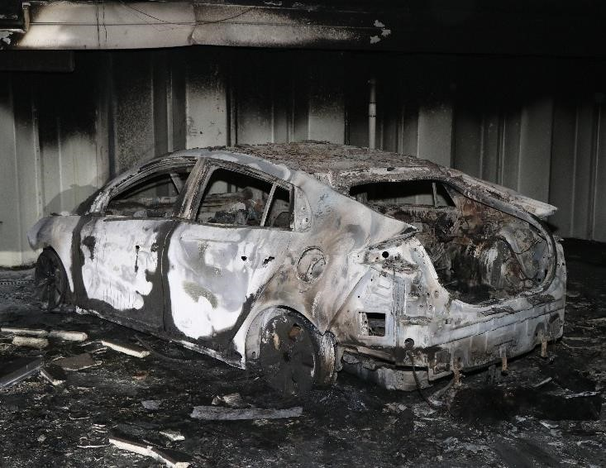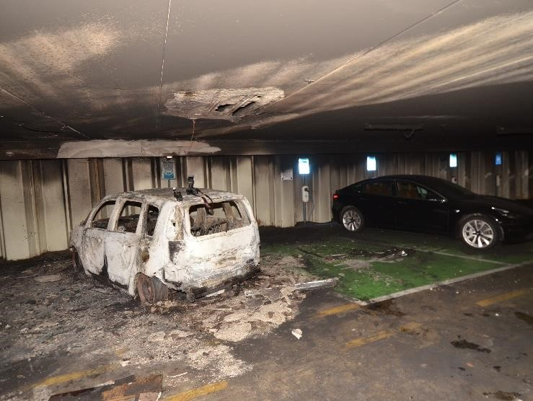
Image 5.2 Burnt Out Citroen C3 Image 5.3 Burned Out Hyundai Ioniq

5.4 Ventilation
After extinguishing both vehicle fires, it is determined by the fire brigade units present that the two burning vehicles are the only two cars that have burned. Parking layer -2 is still filled with a layer of smoke to the ground at that time. The third Officer of Service (300), who has since arrived on the scene, receives from the
Task commander the assignment to come up with a ventilation plan. For ventilation, he receives support from, among other things, the container specialist extinguishing agents from theAmstelveen fire station, the extinguishing robot from the Haaglanden safety region and the fan from the SBH. With these units, the 300 makes a ventilation plan to get and keep -1 and -2 smoke-free.

At the same time, several teams in the car park are ableto switch on the ventilation of the car park. The TS's of Schoorl and Koedijk have contacted the OvD and parking management about this. The commanders go to the technical room at -2 and try to start the emergencyoperation (the emergency mode of the business operations) at the direction of parking management. The TS1 Alkmaar is simultaneously working together with Valet Parking to turn on the fans via the main panel. After some time of trying, a part of the fans will turn on. The sight neemt hereafter. It is not clear by which action exactly the fans were switched on.

Despite the start-up of the fans in the garage, it remains necessary to ventilate additionally. From the entrance on the Wilhelminalaan – where the windis at its back – the ventilation is started. This is done with the fans of Amstelveen and the SBH, which are placed in series to drive the smoke towards the drain on the Vrouwenstraat. This dissipates some of the smoke. Haaglanden's extinguishing robot is used to drive the remaining smoke from the entrance further and further towards the ventilation duct on the Vrouwenstraat side. However, the ventilation capacity of this robot turns out to be so large that the smoke is blown around throughthe parking garage, while the outlets are too small to remove the smoke. Even if the fan is operating at half power, this problem persists, so it was decided to stop its deployment.

After starting the ventilation,the parking layer -2 quickly becomes smoke-free, but because the outflow space is limited, smoke ends up on -1. That is why a fan was placed at -1 to keep this floor smoke-free.

5.5 Nafase
While ventilation is taking place, it isnot clear to the fire brigade units involved what to do with the electric vehicle, because it is unclear whether the battery was involved in the fire. The Hazardous Substances Advisor (AGS) is then brought in. He looks at thevehicle with the WBC and sees a higher temperature at the battery than in the rest of the vehicle, whereupon he comes to the conclusion that the battery is unstable. The AGS consults with the TC, 100 and The Officer of The Police Service (OvDP), after which they jointly decidethat the electric car must be removed from the garage.

The OvDP receives the suggestion from the Operational Center (OC) to request the transport robot of the police from Haaglanden, with which the electric car can be removed from the garage. This is requested by the OvDP after consultation with the OvDB and comes on site with Prio 1. The immersion container of recovery company Vreugdenhil has also been called up. The electric car was then removed from the garage by the police robot. During the installation, the engine fell out of the car. Once outside, the AGS monitors the temperature of the battery with the WBC. Again, the battery is warmer than the rest of the vehicle. The vehicle is then hoisted into the container, which is partly filled with water, and discharged.

At 15:13 the incident was handed over by the fire brigade to the police and municipality.

6 The use of robots
The fire brigade deployment in the Singel garage is characterized by a relatively new phenomenon: the use of robots. This chapter focuses on the use of three robots: the two extinguishing robots of the Amsterdam-Amstelland Fire Department and the Haagl anden Fire Brigade, and the transport robot of the Police Unit The Hague.

6.1 The extinguishing robots of the Amsterdam-Amstelland Fire Department and the Haaglanden Fire Brigade
The possibility that many cars are on fire in the parking garage, the inability to enter due to the dense smoke andthe heard explosions and the message from Building and Housing Supervision about a possible risk of collapse make the Task Commander of the fire brigade decide to call in various specialisms. This includes the use of firefighting robots, which can beused in places where it is too dangerous for firefighters to act safely.
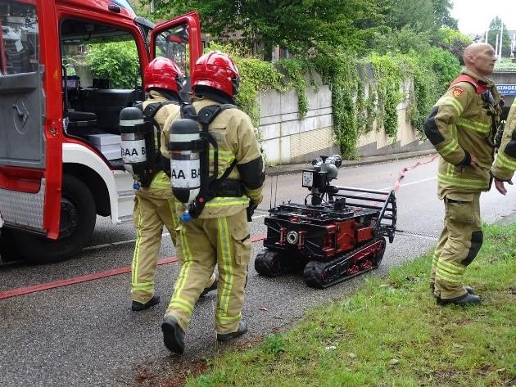
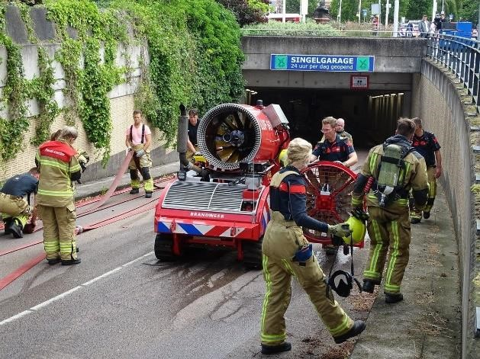
Image 6.1 Left: The extinguishing robot of Amsterdam-Amstelland, right: The robot of
Intermezzo: type
blusrobots

From b
lusrobot

from

Fire brigade Amsterdam Amstelland

This robot is a compact tracked vehicle, which is electrically powered and a
bluskanon has that is fed by the pump of a tanker sprayer.
The extinguishing capacity of
the robot is thus

depending on the capacity of the pump
,

which generally 2000
-
l/min.
2400

From b
lusrobot

from

Fire brigade Haaglanden

This robot is powered by a diesel engine and

is equipped with a large fan
with an extinguishing device that can supply both a bonded jet and a spray jet. The
Capacity is 3500l/min. This robot can both extinguish and only ventilate.

Haaglanden (Photos: Hans Peter Olivier and Evelien Olivier-Wittenberg)
The fire extinguishing robots of the Amsterdam-Amstelland Fire Brigade were then used by the control room.
(BRW AA) and The Haaglanden Fire Department (BRW HGL) were asked on site. In addition to the robots, the third OvD, the 300, is alerted to coordinate the deployment of the special extinguishing agents, including the robots. Brw AA's extinguishing robot is on site approximately forty minutes after an alarm. Upon arrival, the unit is linked to heiloo's TS, which supplies the robot with water. The TC thought that the BRW AA extinguishing robot was equipped with a (thermal imaging) camera, but that turned out not to be the case. After the arrival of the BRW AA extinguishing robot, it was prepared for deployment. At the same time, however, both burning vehicles are found, so it is decided not to use the robot for the time being , but first to expel the smoke with the help of fans to gain visibility and then still be able to extinguish any fires.

Brw HGL's extinguishing robot arrives on site more than an hour after an alarm. This robot was used to first make the parking deck smoke-free and to create visibility for the fire brigade teams. As mentioned in section 5.4, the ventilation capacity of this robot is so great that the smoke was blown around the parking garage, even if the fan was running at half power . It was then decided to stop the use of this robot. In addition to ventilation, the robot was also used to check the concrete pillars with its camera. In the meantime, the fire extinguishing robot of BRW AA was on standby in order to be able to extinguish immediately if necessary. At the time of the firefighting by the fire brigade personnel, no robots were present or deployed on parking layer -2.

6.2 The transport robot of the Police Unit The Hague
Because the AGS measured an elevated temperature at the level of the battery pack of the Hyundai Ioniq, they were afraid of a re-ignition and wanted the car out of the parking garage. The ceiling of the car park was so low that the Hyundai could not be pulled onto a salvage car. That is why, in consultation with the police, it was decided to drag the car out with the help of a robot from the police. This transport robot is used in regular police work to, for example, tow away cars with explosives. With the help of this police robot, the Ioniq was taken out of the garage. The BRW AA robot assisted in this by informing the police robot and its operator.
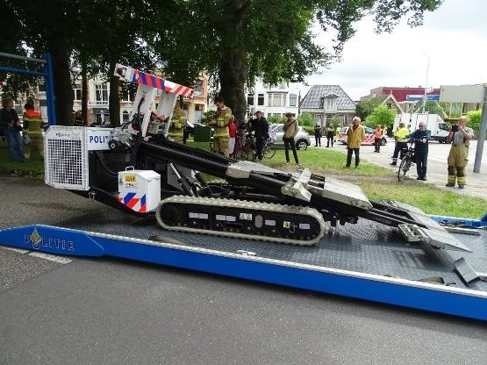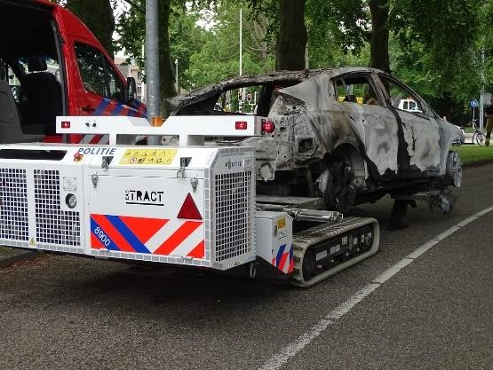

Figure 6.2: the police transport robot. Photos: Hans Peter Olivier and Evelien Olivier-Wittenberg
All three robots are controlled by radio. There is only limited reception in the parking garage, which meant that the operators also had to go into the garage to be able to steer the robots successfully. The operators of the robots of the BRW AA and BRW HGL have therefore carried breathing air. The operator of the police robot was only present in the parking garage when the smoke was expelled.

7 Answers to the research questions
In this chapter, the various research questions are answered, as described in the introduction.

7.1 What was the fire course like?
The exact fire course of both vehicles is not known. No video footage of the fire was available for this investigation. Around 06:22 the first CO is detected and around that time the 112 message comes in that there is a fire in the parking garage. At 09:31 the AC is informed that the fire may be out. This is more than three hours after the start of the fire in the vehicles. The firefighting teams that have been with the vehicles have indicated that the vehicles were (as good as) off.

At both locations where a vehicle has been on fire, the fire has been limited to the vehicle in question. The fact that the parking spaces right next to the burning vehicles were empty and the non-combustible concrete structure have added to this. The temperature of the smoke layer above nearby vehicles, the nearest of which was about four meters away, was not high enough to ignite it or cause fire damage from the high temperature. The vehicles were, after the fire brigade had reached them, almost burned out. In the electric car, flames were still present at the level of the ventilation openings of the battery pack. The battery of the electric vehicle was found to have an elevated temperature for a long period of time, indicating instability.

7.2 How did the fire brigade action go?
The repressive fire brigade action at the fire in the Singel garage was aimed at fighting the fire: an offensive interior deployment follows the quadrant model.

The fire brigade has made several attempts to locate and combat the fires. Immediately at the start of the deployment there was no visibility due to the dense smoke. Nothing could be detected with the thermal imager either. Little or no heat was felt in the smoke. However, bangs or dull thumps were audible, on which the reconnaissance attempts were aborted. The entrances to the parking garage on the site of the escape stairwells on the Kennemersingel and Vrouwenstraat could not be opened from the outside. These accesses could only be used after they had been opened from the inside.

During the incident, Parking Service came up with camera images, showing the suspected locations of the fire. The task commander and the officers on duty decided, in consultation with the commanders, to make a new reconnaissance attempt to locate the fires. During this attempt, various people explored from all entrances to the parking garage. Soon after starting this reconnaissance attempt, both burning vehicles were found, which were already virtually burned out at that time. Here and there is still some quenching.

After extinguishing both vehicle fires, the relevant fire brigade units found that the two burning vehicles were the only two cars that burned. Parking layer -2 was at that time still filled with a layer of smoke to the ground.
To ventilate, the sliding doors for cars were opened and fans were installed. These were set up in series to drive the smoke towards the drain on the Vrouwenstraat. The fire brigade teams present also succeeded in switching on the ventilation of the parking garage. As a result, some of the smoke was emitted. In order to expel the smoke that lingered further towards the ventilation duct on the Side of the Vrouwenstraat, the Haaglanden extinguishing robot was used. Parking layer -2 soon became smoke-free, but because the outflow space was limited, rook ended up at -1. For this reason, a fan was then placed at -1 to also make /keep -1 smoke-free.

The unstable battery and use of the robots and their influence on firefighting operations are discussed in more detail below.

7.3 How did the use of robots in combating the incident go?
The extinguishing robot of the Amsterdam-Amstelland Fire Department was initially not deployed on parking layer -2, but was on standby during the ventilation phase and the recovery of the electric feed.
-2 smoke-free and thus create visibility for the fire brigade teams. However, the ventilation capacity of this robot turned out to be so large that the smoke was blown around by the parking garage, so it was decided to stop the use of this robot. Both extinguishing robots were only deployed after the two cars involved had been extinguished by fire brigade teams; they have therefore made no contribution to the effective fight against the fire. The police robot has been successfully deployed to tow the electric vehicle out of the parking garage.

A limitation that occurred in the deployment of all three robots was the limited reception in the parking garage. As a result, the robot's operators had to go into the garage with them in order to control the robots.

7.4 What was the involvement of (the battery pack of) the electric car in the fire?
The battery pack of the electric car has contributed to a fire in the Hyundai Ioniq. The battery pack of the electric car, which is completely burned out, was involved in the fire due to the burning of other parts of the car. In the case of the electric vehicle, a larger area of the concrete structure was damaged. Above the conventional vehicle, less surface area of concrete is damaged, but the concrete has fallen away over a larger thickness. In addition, the fact that an electric vehicle was involved in the fire led to the use of the transport robot to tow it out of the garage. The immersion container was then used to cool the battery of the electric vehicle.

7.5 What were the existing fire prevention facilities?
The determination of which facilities are present according to the building permit has taken place on the basis of the available information and the actual situation in the parking garage.
> | Brandcompartimenten < 5000 m² (4383 m²)  - WBDBO between the fire compartments for 60 minutes.  - Fire separations to the (escape) stairwells have a fire resistance of 30 minutes.  - Fire-resistant sliding doors on adhesive magnet
> | Fire alarm system, full monitoring with notification to the North Holland Control Room
> | Evacuation alarm system with signal transmitters
> | Four (escape) stairwells; a walking distance to the access of each (sub)fire compartment < 40 meters
> | Portable extinguishers: hand fire extinguishers
> | Emergency and transparent lighting
> | Dry extinguishing pipe
> | Fire corridor with fire panel.

Other facilities:
> CO and LPG detection
> Ventilation system: there is no ventilation system designed to expel the smoke in the event of a fire. Only use ventilation is available, controlled by CO and LPG detection.
> Transparencies with flashlight and the text 'Turn off the engine garage leave.'

The functioning of the fire prevention facilities was not assessed in this study. Closing the fire-resistant sliding doors has limited the smoke spread to parking layer -2. There are indicators that indicate that the fire alarm system did not function fully during the incident: for example, no direct notification took place to the Noord-Holland Control Room and log data show that the fire alarm system did not receive an answer from different installation components on the two parking layers.

8 Interpretation

8.1 In advance
It is not often in the Netherlands that a fire breaks out in an underground parking garage. It is generally difficult for the fire brigade to fight such a fire . There are many factors that determine the course of the fire and the combatability of the fire. In addition, there may recently be electrically powered vehicles in the parking garage, which may be on the charger.

The number of fires for which (inter)national reports are available is limited. It is striking that these fires can usually be extinguished in the end, albeit with great difficulty. It is important to understand which circumstances have played a role in this, so that tools can be distilled from it for the fire-safe design of parking garages and the fight against parkingwires. In addition, such insights also provide knowledge with which the simulation models that have been developed can be tested against practice. It is therefore of great importance that we (continue to) investigate these types of fires – albeit limited in this case – so that we document them and learn from them where possible.

This report on the fire in the Singel garage in Alkmaar contributes to that learning process. It is good to realize that it came about after a relatively limited investigation and provides information about a specific incident, so that the informationfrom it cannot simply be generalized to other situations.

8.2 Important aspects of this fire
Broadly speaking, a number of aspects of this fire in Alkmaar played a crucial role in the course of the fire and the fight against it:
- The extent of the spread of fire and smoke was small. The fire has been limited to the two vehicles in which the fire originated, presumably as a result of arson. The smoke spread has been limited to one compartment (parking layer –2).
- Fire doors were installed in the garage that closed off the parking layer at -2 from the rest of the building. The entrance doors to the stairwells were also closed. As a result, both remained smoke-free. As a result, the fire brigade was eventually able to reach parking level -2 in a safe way via these stairwells.
- The garage was located under water, so the impact on the environment was small.
- The fire was finally extinguished after more than 2 hours. The vehicles were already almost completely burned out.
The fact that an electric car turned out to be involved in the fire had little influence on the direct firefighting in the garage. In the 'aftermath', however, all the more so because of the re-ignition risks, which required a long-term cooling of the battery pack, as well as towing the electric car out of the garage and immersing it in a container.

8.3 Application of the basic principles of firefighting
For the interpretation of the learning points in the fight against a fire, we follow the basic principles of firefighting. We look below at which refinements or interpretations of the basic principles for parking garages can count as learning points from this fire.

- From the beginning of the fire brigade deployment, a worst case scenario has been taken into account; this is evident from the rapid upscaling. The learning points of previous fires are involved in the 'stop and think after moment'. This fire in the parking garage was not a standard fire with a standard deployment.
- A large outdoor exploration has been done. They looked for all possibilities to enter the building in a safe way and to find out where the fire was located. In principle, the outdoor exploration should lead to an outdoor deployment.
- For the basics, there are three main exploration questions: Is the location known? Is the location accessible from the outside? Is there enough cooling power available? A negative answer to one or more of these questions will lead to the conclusion that the fire cannot be fought. An indoor deployment can then be considered, provided that a number of conditions are met: a short distance and a space with a small volume. That was not the case here, which would in principle lead to the conclusion that both an offensive outside bet and an offensive inside bet would not be possible. In fact, that has indeed been concluded, because teams have been withdrawn several times, because there was no visibility and explosions were heard. In the document it was also not clear where the source of the fire was located. It is therefore not surprising that the fire brigade has taken a step back here to make a new plan. There are three important aspects that have helped tobe able to make a relatively safe indoor effort:
> The camera images that later became available helped to get a picture of the location and size of the burning cars.
> Because the smoke spread was limited, parking layer -2 could be approached smoke-free. However, parking layer –2 itself was filled with smoke.
> The distance from the access to the burning cars was relatively small.
This method is a space-for-space exploration goal that is described in the basic principles.
- The edge power of a fully burning modern car is between 6 and 10MW. For extinguishing a car, low pressure is therefore required. The choice of the fire brigade for a low-pressure (LD) deployment was therefore very justified. It should be noted that international (CTIF) advocates the use of two jets of low pressure per vehicle for modern cars. For two vehicles, this is at least 4 LD. Of course, this applies to a burning vehicle that burns at full power (Institute for Physical Safety, 2020).

8.4 The influence of the presence of an electric vehicle
- We know that an electric vehicle has a different fire course than a conventional vehicle. For example, torches can form, explosions occur and parts of the accu package fly around. When the fire brigade made a new attempt to approach the source of the fire after an hour, explosions were still heard. When the fire brigade finally found the vehicles at -2 after two hours, both were almost completely burned out.
- We know that when a battery pack has been involved in a fire, it can re-ignite for a long time afterwards. It remains difficult to determine exactly when that danger has passed. It will therefore always be necessary to safely remove the vehicle from the garage. In this case, a special transport robot of the police has offered solace. That is a practical solution.
- After it became known that an electric vehicle was involved in the fire, it was scaled up and special means were requested on site, such as a water immersion tank from Vreugdenhil Berging.
- It was also asked for the unmanned vehicles (extinguishing robots) with the idea that they could extinguish the fire. From a learning perspective, these are unfortunately not set and we can therefore not record any experiences about extinguishing with the robots.

8.5 Looking at the whole
- In this fire, the presence and operation of smoke doors and the fact that the fire has remained limited have been crucial. As a result, the fire brigade had time for extensive reconnaissance, the fire was extinguished by itself and the size was limited to two burned-out cars.
- The fire brigade acted in accordance with the basic principles of firefighting, whereby the fire was initially uncontrollable during the first two hours.
- The fact that an electric car was involved in the fire in this case had hardly any influence on the direct response. After 2 hours, the electric car was almost burned out. The presence of electric vehicles may have had a mental impact on decision-making. After all, it is known that these are difficult to extinguish and cause explosives. Moreover, there is still little experience with the effect of burning electric cars and combating them in a parking garage.
- In the aftermath, the involvement of the electric vehicle did have an effect. For the final handling of the incident, a recovery truck with a submersible container and a transport robot from the police were necessary.
- It is interesting to find out in more depth how it is possible that the fire has remained so limited. The fire course does not correspond to most model studies and simulations of fire course in parking garages. If we have more knowledge about this, it provides tools to be able to estimate in the future whether an indoor deployment can be safe and effective and under what conditions.
- An important learning point is that waiting to deploy is a serious option in the event of parking garage fires. Waiting until the fire power and temperature have dropped also gives combating possibilities. However, it is important to take two things into account:
  - The number of vehicles that are in the garage. If it is full, the chance of fire spread is of course greater than if there are few cars in it. In terms of the fire triangle, that's "taking away" the fuel side.
  - What the impact on the environment could be (for example, on the stability of the structure).

Ricardo Weewer, reader Brandweerkunde
Nils Rosmuller, Professor of Energy and Transport Safety

Literature
Huang, P., Wang, Q., Li, K., Ping, P., & Sun, J. (2015). The combustion behavior of large scale lithium titanate battery. Scientific Reports, 5, 1–12.
http://doi.org/10.1038/srep07788.
Institute for Physical Safety. (2017). Basis for fire safety. The substantiation of fire protection in buildings. (2nd ed.). Arnhem: IFV.
Institute for Physical Safety. (2020). Fire safety of parking garages with electrically powered vehicles.
Li, H., Peng, W., Yang, X., Chen, H., Sun, J., & Wang, Q. (2020). Full-Scale Experimental Study on the Combustion Behavior of Lithium Ion Battery Pack Used for Electric Vehicle. Fire Technology. http://doi.org/10.1007/s10694-020-00988-w.
Ping, P., Wang, Q. S., Huang, P. F., Li, K., Sun, J. H., Kong, D. P., & Chen, C. H. (2015). Study of the fire behavior of high-energy lithium-ion batteries with full-scale burning test. Journal of Power Sources, 285 (February 2019), 80–89.
http://doi.org/10.1016/j.jpowsour.2015.03.035.
Sun, P., Bisschop, R., Niu, H., & Huang, X. (2020). A Review of Battery Fires in Electric Vehicles. Fire Technology. Springer. http://doi.org/10.1007/s10694-019-00944-3.

Appendix 1 Timeline

The timeline below has been created based on the VRNHN data from the status times, the incident report, the notepad and information from the vrnhn learning table's evaluation meeting. It provides a global overview of the course of the incident.

Where possible, the exact times are given. When the exact moment of an event is not known, an attempt has been made to place this accurately as possible between the present and subsequent event of which a time is known. This is indicated by the time 'unknown'.

Moment | Event | Source
06:23 | First alarm fire building, alarm 2x TS (of which one TS4), HW and OvD | Incidentrapport
Onbekend | Driving, the first TS (TS1 Alkmaar) sees smoke coming from the ventilation duct at the Vrouwenstraat, there is no smoke coming from the hatch, which is closed. The section along the Kennemersingel is also closed. | Evaluation
06:28 | First TS on site (TS1 Alkmaar) | Statustijden
Onbekend | TS1 Alkmaar is located at the entrance at the Ritsevoort, where the fire alarm panel is located. Will be taken care of by police on arrival. The police indicate that there is light smoke in the stairwell and it would burn downstairs. The crew of the TS1 Alkmaar goes down the stairwell. No smoke can be seen at -1. At -2, smoke hangs to the ground. No current in the smoke is observed, the plow hears banging / thumping. Also, at -2, the sliding door opens automatically. Plow goes back up, puts lage pressure and goes down again. Upon arrival at -2, the door will no longer open automatically. The team takes a step inside and hears thumping again. There is no visibility, no current is perceptible and there is no increased temperature feelingd. Nothing can be seen on the WBC. Then decides to withdraw. | Evaluation
06:29 | Great Fire given by TS1 Alkmaar | Notepad
06:29 | Alerting AGS and TS Heiloo | Incidentrapport
Onbekend | 100 listens in and switches to his plan+ based on the sitrap of the TS1 Alkmaar (Further upscaling, 2nd OvD and incident division)
06:30 | Request for 200 by approaching 100 | Notepad
06:33 | Aerial platform on site. (HW is put away and team is added to team first TS, so that TS4 is made into a TS6) | Statustijden
06:34 | ZGB and GRIP 1 given by 100, indicates AC that there is a fire on  -2 | Notepad
06:34 | Alarming Task Commander (TC), LCOPI and TS Stompetoren | Statustijden
06:35 | Second TS on site (TS2 Alkmaar) | Statustijden

Onbekend | TS2 Alkmaar is exploring along shutters on Kennemersingel and Vrouwenstraat, both are still closed and cannot be opened from the outside. | Evaluation
06:37 | 100 on site | Statustijden
06:37 | 100 makes a request for Building and Housing Supervision to be placed on site. | Notepad
Onbekend | 100 does a rough reconnaissance with service vehicle. At the main entrance Wilhelminalaan no smoke can be seen. Slight smoke development at Ritsevoort.  At Vrouwenstraat black smoke visible from ventilation duct. | Evaluation
06:42 | 200 on site | Statustijden
Onbekend | TS Heiloo on the spot, is taken care of by the 100 and sent to the main entrance Wilhelminalaan. Assignment is to explore for possible persons inside. Coordination with 200 that coordinates the 200 Wilhelminalaan and 100 at Ritsevoort. 100 and 200 coordinatethe then two units. | Evaluation
06:45 | TS Stompetoren on site | Statustijden
Onbekend | Consultation 100 with TS1 Alkmaar and TS2 Alkmaar. TS2 Alkmaar is ordered to do reconnaissance from the manifold that the TS1 Alkmaar has taken. A water cannon is also prepared at -2. A small piece is explored inwards, but there is still no view and explosions are still heard (dull blows). There is therefore no further exploration. No heat is felt in this phase. | Evaluation
Onbekend | TS Heiloo is exploring the Wilheminalaan stairwell, which is virtually free of smoke. From the stairwell they end up on the intermediate platform at sliding doors on -1 and -2, which are closed. Through the wicket door in the sliding door they explore -1 and -2. At -1 they see no smoke, -2 is full of smoke up to the knee. Clockwise and counterclockwise, approximately up to 10 meters with LD is explored. | Evaluation
06:51 | TC on site | Statustijden
06:52 | AGS on site | Statustijden
06:54 | Sitrap 100 to AC. NB: multiple explosion heard at -2, shifts pull back to -1. | Notepad
Onbekend | TS2 Alkmaar explores via -1 via the emergency entrances at the Kennemersingel and the Vrouwenstraat to the doorway at -2, without radius and with WBC. In both stairwells there is very light smoke, from the door entrance there is no view, not even via the WBC. There is no pressure behind the smoke andno heat is felt. | Evaluation
Onbekend | TS Stompetoren is deployed at the Wilhelminalaan and do an exploration up to -2. She encounters the TS2 Alkmaar at -1. | Evaluation
07:05 | Extinguishing robot with OvD VRAA requested | Notepad
07:14 | Foam container requested due to possible foam extinguishing | Notepad
07:16 | 2nd platoon fire requested by TC | Notepad
07:16 | Peloton alert: TS Schoorl, TS Limmen, TS Koedijk and TS Bergen | Statustijden

07:18 OvD Brand parking garage De Appelaar in Haarlem requested Notepad
Unknown 100 and TS1 Alkmaar receive information from camera images of Evaluation Valet Parking Service showing that cars have been set on fire. It is told by parking management that it would be three cars. It is not clear whether more cars have caught fire as a result. It is also indicated that one of the cars that are burning right next to the access must be at -2 from the ritsevoort entrance.
07:28 TS Bergen and TS Koedijk on site (2nd platoon) Status times
07:34 TS Schoorl and TS Limmen on site Status times
07:35 First COPI - around this time it becomes clear that there are no more persons Report TC in the building
07:37 Extinguishing robot Haaglanden requested Notepad
Unknown The TS1 Alkmaar opens the shutters of the emergency entrances of the Evaluation Kennemersingel and Vrouwenstraat via -1.
Unknown TS Koedijk is instructed to put down smoke during the Evaluation
Women's Street. She takes off the turbulence pump and does a short reconnaissance to the door at -2. Through the window in the door there is no view into the parking garage. There is virtually no smoke in the stairwell.
Unknown TS Koedijk takes LD to -2 and goes back to the 100. Evaluation now has a map showing possible locations of the vehicles that have been set on fire. Consultations are held with the 100 and TS1 Alkmaar whether they dare to go inside, both answers positively.
Approx. TC and 100 tune in to arrive at a go or no go between 8:08 and Evaluation 08:08:00 half 9. Until then, the teams are given time to explore.
Unknown TS2 Alkmaar is instructed to explore from the entrance Ritsevoort from the Evaluation farpart of the TS1 Alkmaar to the car that catches fire
next to the access from that side is at -2. She soon finds the burning car and extinguishes it. It turns out that this is not an electric car, but a car that is parked directly behind the parking spaces for electric vehicles.
Unknown TS Heiloo notices that the temperature rises during the exploration and Evaluation withdraws from it. She does not know that an extinguishing is being carried out at the same time.
Unknown TS Stompetoren is deployed from the Kennemersingel to do an exploration from there, together with TS Bergen.
Unknown TS Koedijk is exploring from the Vrouwenstraat with two Evaluation lengths clockwise and counterclockwise along the wall. No burning vehicle is found.
Unknown TS Schoorl has stood wachten om possibly. TS1 Alkmaar or TS1 Alkmaar Evaluation to be discharged. Then offer to support TS Koedijk, which is positively responded to. TS Schoorl then also positions itself at the entrance on the Vrouwenstraat.
08:15 On indication OvD Brand parking garage De Appelaar container with Notepad fans Amstelveen requested.
Unknown TS Koedijk and TS Schoorl agree on exploration, after which Koedijk Evaluate explores further to the right and Schoorl counterclockwise with an extra length. To the right, Koedijk meets the team of TS Stompetoren. TS

Schoorl meets the team of Bergen who crossed straight from the Kennemersingel. TS Bergen is thus right on the burning vehicle. The car is completely burned out, but still burns on the inside. It is clear fairly quickly for the Bergen team that it is an electric car. The fire is extinguished by the team.
08:17 Alarm 300 Status times
09:00 300 on site, coordinates with 100 and 200 and is instructed to deal with specialist Status Times equipment that is approaching and to work with a ventilation plan. The image is that fire seems to be under control, but more visibility is needed. The fans of the parking garage itself do not yet work.
09:31 Sitrap to AC by 100 NB: situation seems under control, possibly the Notepad fire is out. No casualties, the fire brigade is busy in the entire garage.
Ca. Commanders of Schoorl and Koedijk are in contact with Evaluation
10:00:00 parking management over the fans and go together to TS1 Alkmaar technical room to try to get the fans on. The TS1 Alkmaar is simultaneously working on parking management at the panel to get the fans on. Through which action this succeeds is unclear, but some of the fans then come into operation.
Unknown Shortly after the start of operation of the fans, evaluation ventilation is also started using the fans of Amstelveen and Zaandam. With the fans (in series) ventilation is started, with the wind at the back from the Wilhelminalaan towards the drainage at the Vrouwenstraat. The effect is good, but because smoke still lingers, haaglanden's robot is used to expel the smoke from right to left.
Amsterdam's robot remains on standby for any furtherextinguishing.
Unknown In addition to ventilation, the robots are also instructed to evaluate the pillars for cracks in consultation with the structural engineer. Cracks do not appear to be in it, after which it is assumed that there is no risk of collapse.
Unknown TS Schoorl is going to look again at the electric car with WBC. Evaluation is still measured a lot of heat in the car.
Unknown AGS is brought in to determine what should be done with the car Evaluation. The AGS measures for CO and looks at thecar with the WBC. CO is then not measured, but heat from the battery.
10:33 Request fire container Vreugdenhil for electric vehicles Notepad
Unknown The AGS coordinates in bonnet consultation with, among other things, 100 and OvDP and decided Evaluation is that the car must be taken out of the garage.
Unknown OC Police come up with the suggestion to use a police robot. Interview OvDP and OvDB coordinate this, after which OvDP requests assistance from the OvDP police robot from Haaglanden. Prio1 will be on site.
11:37 Fire master, only the electric car still has to be taken out Notepad
14:15 The electric vehicle is removed from the Evaluation garage with the help of the police robot . The car is still smouldering.
Unknown The car is hoisted into the container by Vreugdenhil. At the battery Evaluation of the car, a decent temperature is still measured. That is why water is sprayed into the container before transport starts.
15:13 | Incident handed over to the municipality and police. | Notepad

Annex 2 Overview of the units concerned

The image below shows an overview of the units deployed.

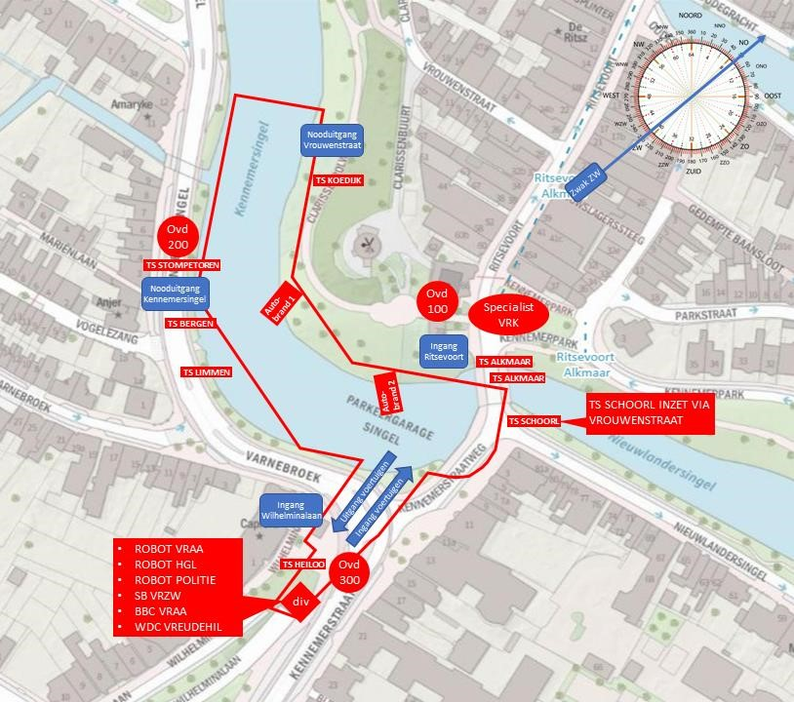

Appendix 3 Articles from the Building Decree 1992
Art. 300 Limitation of fire spread
A building, in so far as it forms a space accessible to humans, covered and completely enclosed by walls, must be arranged in fire compartments in such a way that a fire started in that building cannot spread within a short period of time to another part of the building or to another building.
Art. 302 Limiting the spread of smoke
A building, in so far as it forms a space accessible to people, covered and completely enclosed by walls, must, depending on its purpose and size, be arranged in smoke compartments in such a way that, in the event of a fire, smoke cannot spread within a short time to another part of the building or to another building, the walking distance, measured along the shortest route, to the exit of a smoke compartment is limited and that a space through which an escape route leads remains sufficiently free of smoke.
Art. 303 Flights in case of fire
A building, in so far as it forms a space accessible to humans, covered and enclosedby walls, must, depending on its purpose and size, be arranged in such a way as to provide sufficient opportunities for escape.
Art. 304 Establishment of flight facilities
Without prejudice to Article 289, third paragraph, an escape option as referred to in Article 303 must be arranged in such a way that, in the event of a fire, users of the building can flee effectively and safely within a reasonable time to the site adjacent to the building.
Art. 305 Prevention and reduction of accidents in the event of fire
A building, in so far as it forms a space accessible to people, covered and completely enclosed by walls, must, depending on its intended purpose and layout, be arranged in such a way that persons present in the building can leave the building within a reasonable time within a reasonable time of their own accord or be rescued by the fire brigade within a reasonable time.
Art. 306 Firefighting
Depending on its purpose and size, a building must beequipped in such a way that a fire can be extinguished within a reasonable time.

Appendix 4 Examination of the Hyundai Ioniq battery pack
Vehicle battery pack
The Hyundai Ioniq in question was registered in January2018 and equipped with a Lithium-ion polymer battery pack with a capacity of 28.0 kWh. The battery pack consists of a metal casing containing four battery units. These units are again composed of three modules, which in turn are built from metal cases with two pouch cells in each case. See Figure B4.1 for a schematic representation of such a battery pack and B4.2 for an example of two pouch cells.
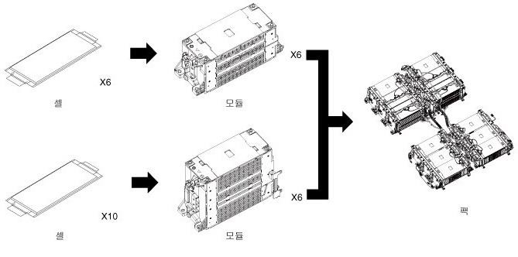

Figure B4.1 Composition of a battery pack
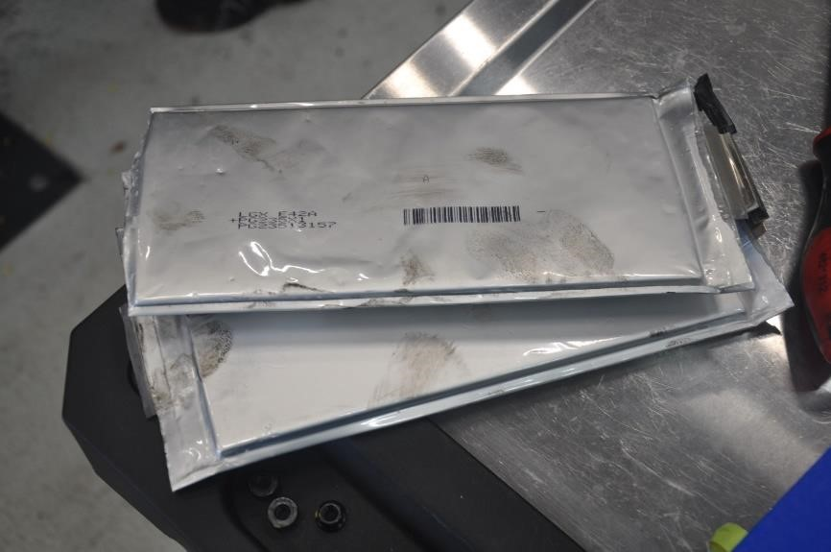

Figure B4.2 Example of two pouch cells
When the vehicle is switched off, the plus and minus of the battery pack are disconnected. If one airbag is activated, the battery pack is automatically disconnected. Emergency services can disconnect a safety plug in the rear seat to achieve the same effect (orange with green on Figure B4.3).

The battery pack has a metal casing and is attached to the metal of the body of the auto. The battery pack is air-cooled by some openings on the top. At these locations there are open connections between the car and the battery pack. Air is drawn in at the passenger seats and passed through the battery packoutside. On the back is the connection for charging and on the front the connections for the operating system. The underside is completely closed and made of metal. How much space there is on the top and bottom between the accueenhedand the metal outside of the battery pack has not been measured. Figure B4.3 shows an instruction model of the battery pack. With the blue arrows, air is supplied and with the red arrows removed.

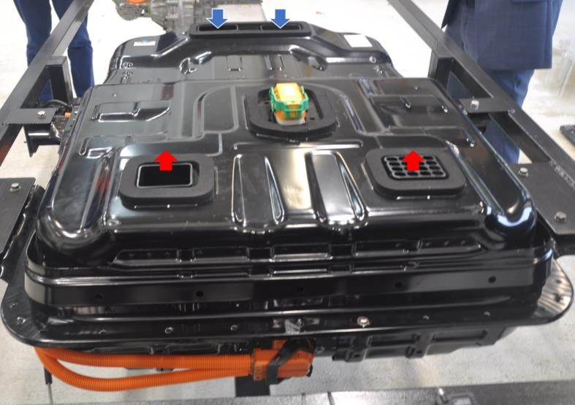

Figure B4.3 Battery pack from the rear
On Image B4.4 below the bottom of the battery pack is visible, on the left of the photo the control system (the metal-colored part).

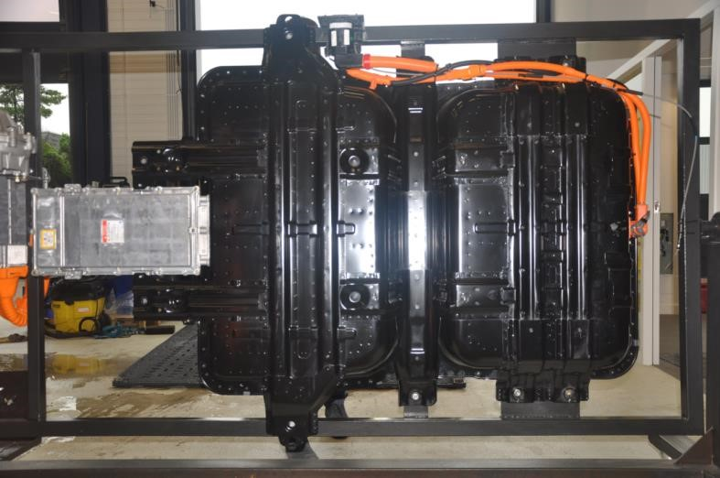

Figure B4.4 Bottom of the battery pack

In the instruction model, the battery models are present at the top two positions. The bottom two positions of the instruction model are empty.

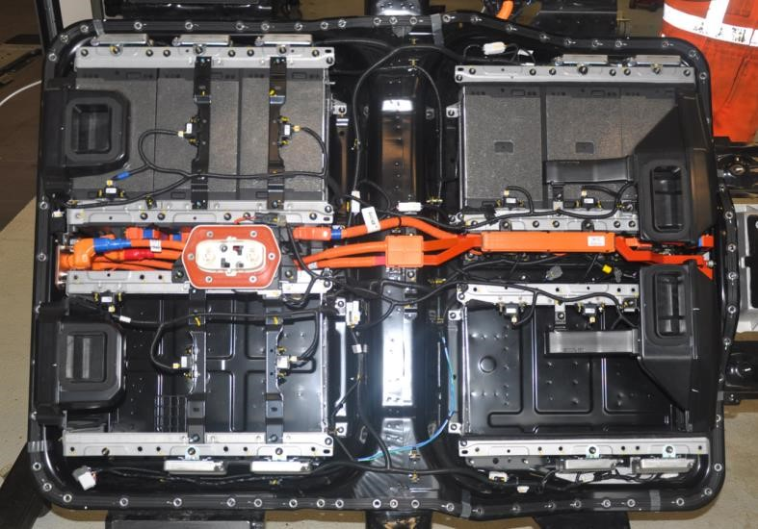

Figure B4.5 Opened battery pack viewed from the top
A battery module is made up of threesingles (see Figure B4.6) and contains a ventilation space between the metal cases that make up each unit (see Figure B4.7).
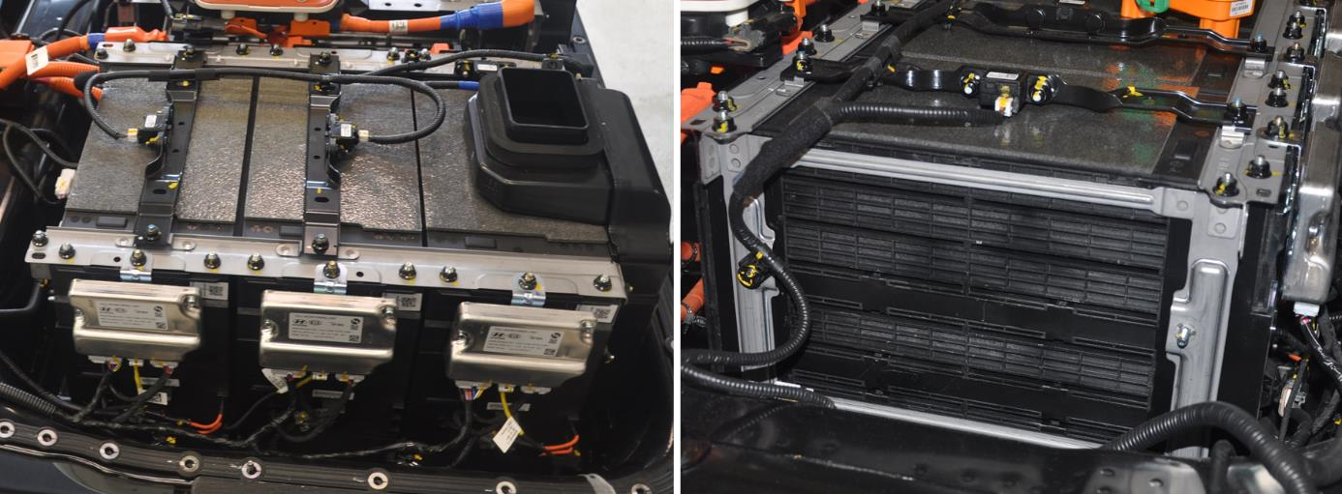
Figure B4.6 Three units Figure B4.7 Ventilation space
Battery pack research
Immediately after the vehicle arrived at hyundai's research center, it was clear that reading the battery pack was no longer possible. The connection to the battery pack and the battery pack itself were completely burned. The battery pack has been disassembled by specialists from Hyundai Nederl.

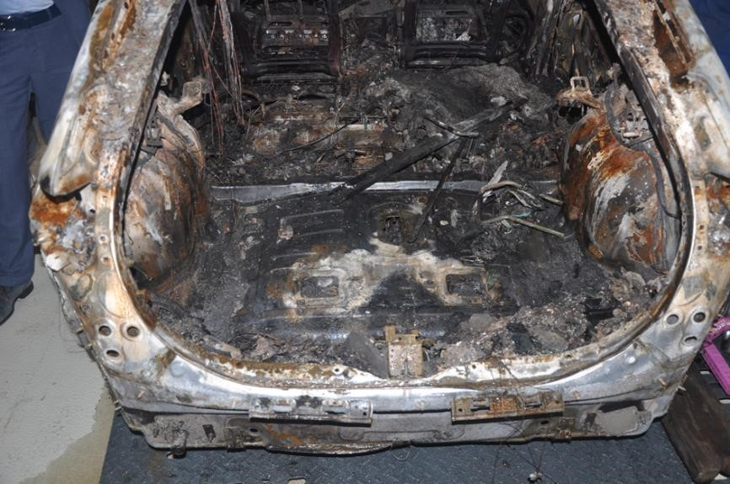

Figure B4.8 Trunk and passenger compartment of the vehicle
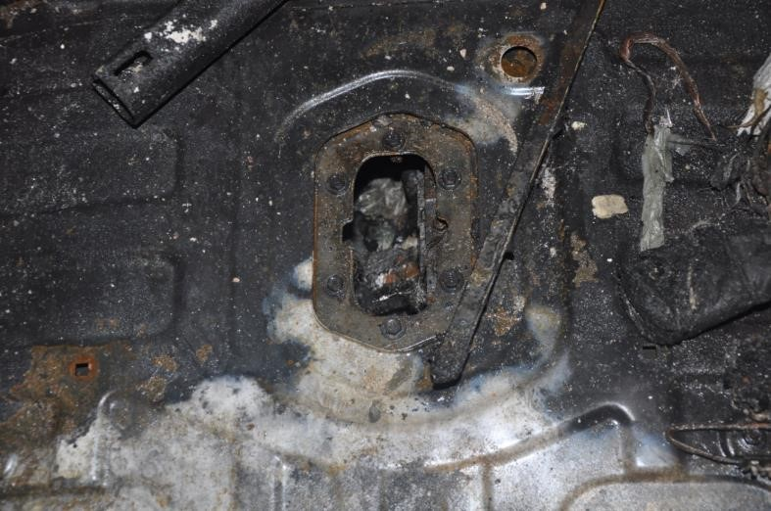

Figure B4.9 Reading the position of the safety plug / connection
The battery pack is not the same height everywhere. The part positioned under the trunk of the vehicle is higher than the part under the passenger seats. No details have been detected on the underside of the battery pack.
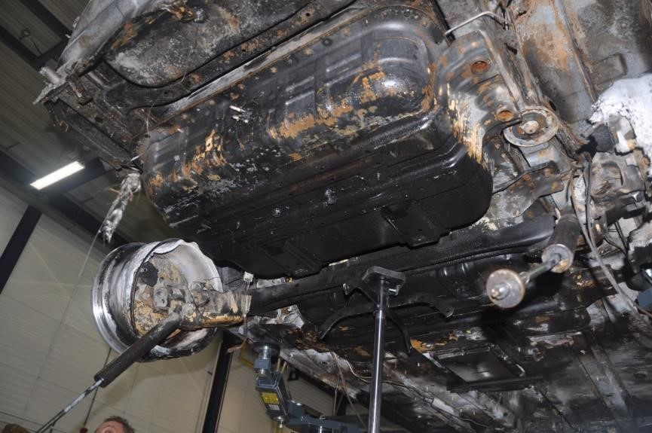

Figure B4.10 Part of the battery pack under the trunk

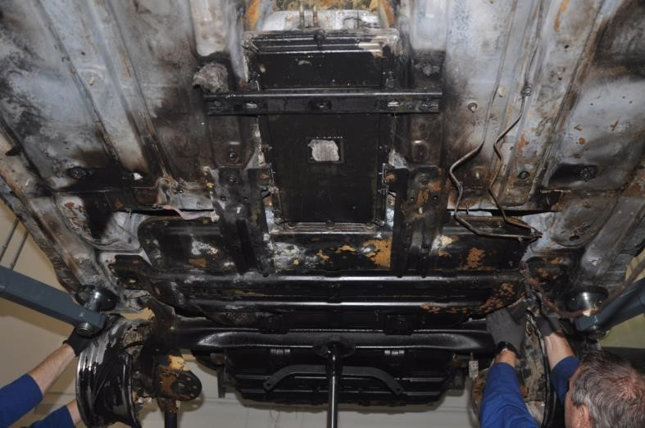

Figure B4.11 Part of the battery pack under the passenger seats
In Figure B4.12, the composite photo shows the underside of the car's bodywork. Notabled is the clean burned part at the location of the air vents. At one location, circled in yellow, a hole was created in the metal as a result of the fire.
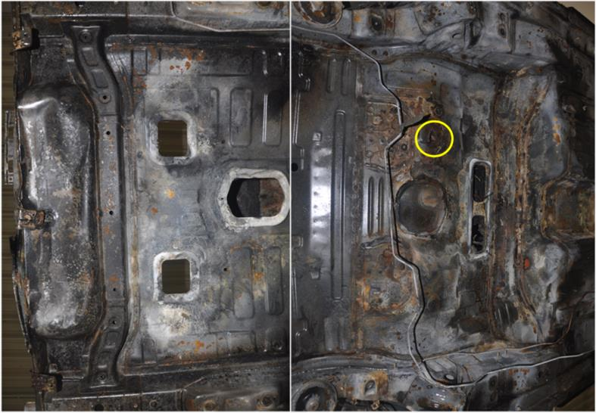

Figure B4.12 Underside of the bodywork at the location of the battery pack
Afew holes have appeared at the top of the battery pack. The largest hole is at the location where a hole has arisen in the body of the car. See Images B4.13 and B4.14, where the holes are circled in yellow.

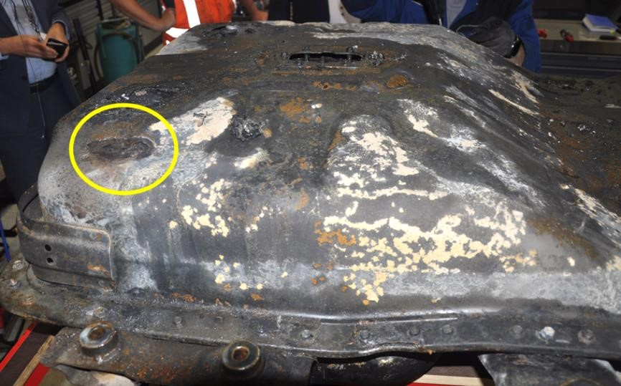

Figure B4.13 Got in the part of the battery pack under the trunk
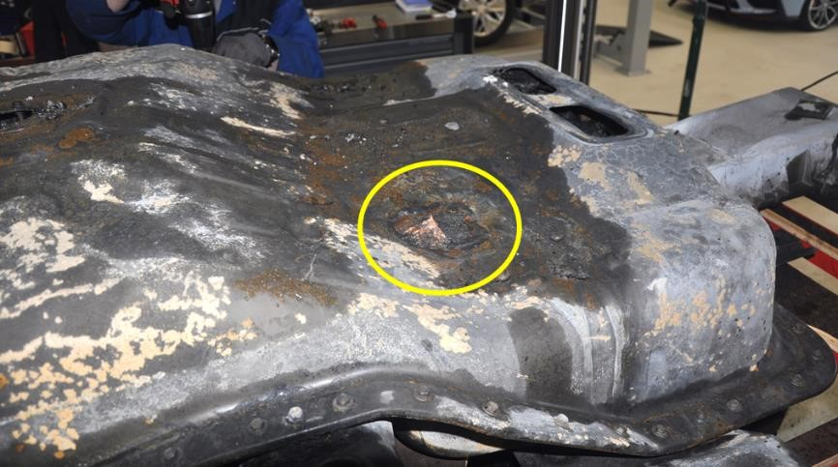

Figure B4.14 Hole in the part of the battery pack under the passenger seats
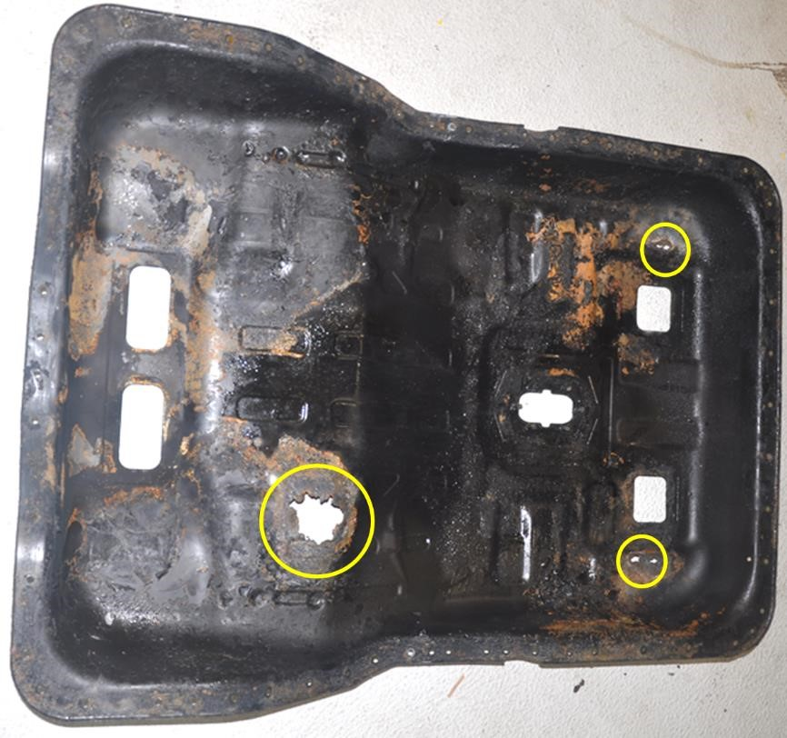

Figure B4.15 Top of the battery pack

The top of the battery pack has been removed to view the inside. On the photo in Figure B4.15 on the previous page it is visible that holes have arisen in the metal of the top of the battery pack at three different locations. Striking is that the coating / paint on the metal at the location of the battery units has partly burned away. At the largest hole, at the bottom left of Figure B4.15, the top of the battery unit is visible. At the level of this hole, a hole has also been created in the body of the car. The edges of the hole in the metal are different on the side of the body (outside) than on the side of the battery units (inside). The metal appears to have melted on the outside (see Figure B4.16), whileon the inside the edges look 'sharp' (see Figure B4.17).

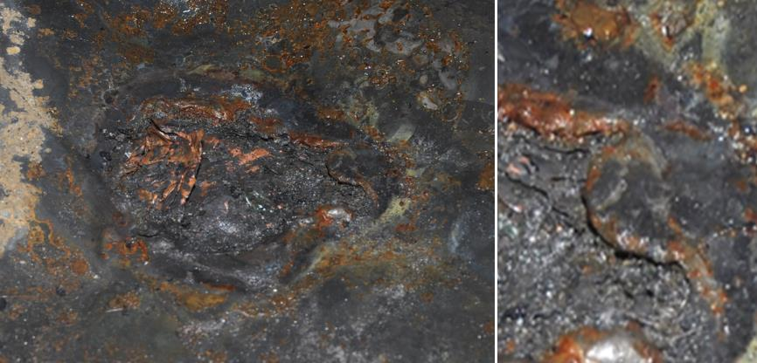

Figure B4.16 Holes seen from the outside of the battery pack
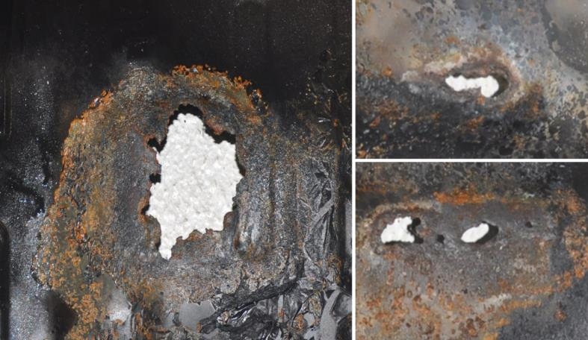

Figure B4.17 Holes seen from the inside of the battery pack
After removing the sideof the battery pack, the battery units are visible (see Figure B4.18). It is striking that the top is particularly damaged at the location of the ventilation openings in the battery pack. Also, the top case of each battery module of the four accu units is convex (see Figure B4.19). The probable cause of this is the bulging of pouch cells before they collapse. As far as visible, most cases containing a pouch cell are deformed. By standing up, parts mayhave arrived at the metal casing of the total battery pack and the fire burned away the insulators between the different metal parts.

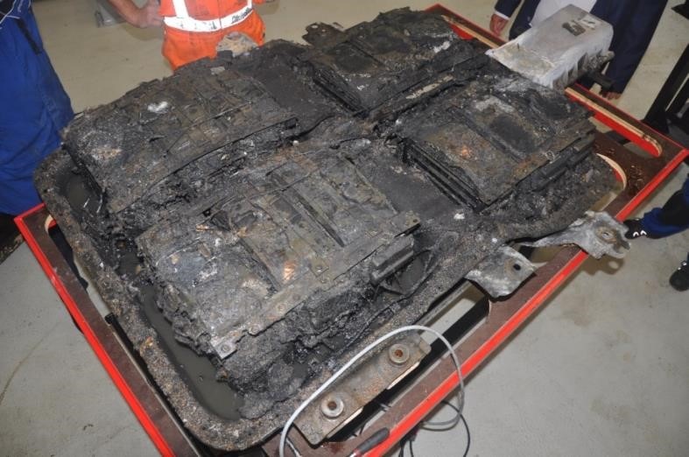

Figure B4.18 Inside of battery pack with the four battery units
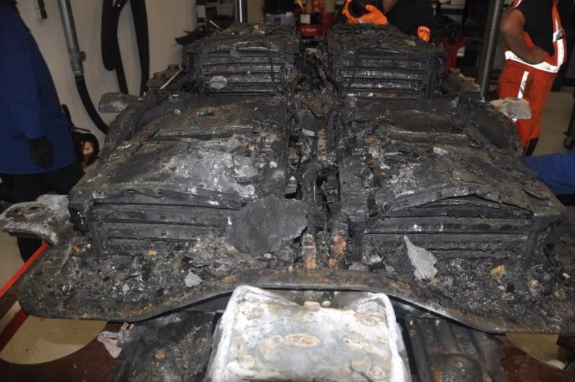

Figure B4.19 Convex positioning from the top of the battery units
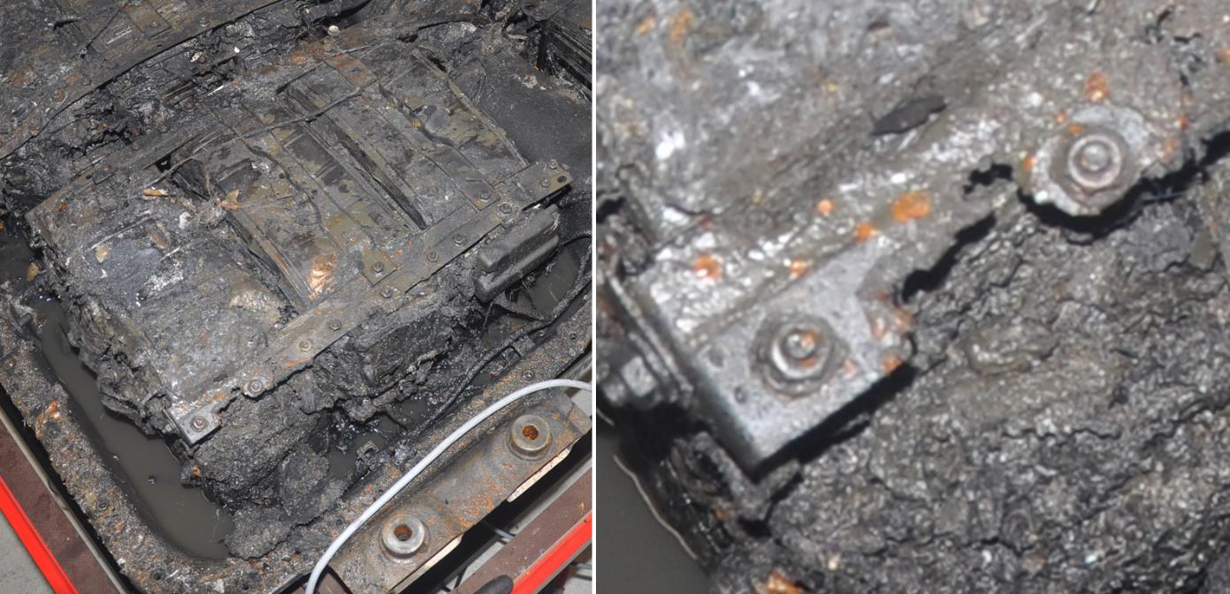

Figure B4.20 Top of the battery unit with the damaged metal rail
From one of the battery units, the metal rail with which the cases are fixed in the battery unit is partly melted away. The position of this rail corresponds to that of holes in the metal top of the battery pack. The spherical part of the batterypack is higher than this rail.

The fire burned through three layers of metal in one location: the case (housing) in which the pouch cells are located, the outside of the battery pack and the body of the car. It is still unknown what kind of metal or alloy of metal the shell of the entire battery pack consists of. Sheet steel has a melting point of 1450 °C. A study on the fire behaviour of lithium-ion batteries (Ping et al., 2015) shows that temperatures of 1500 0 C can be reached at 100 mm of a battery for a short period of time. In an experimental study into the fire behaviour of a lithium-ion battery pack of an electric car (Li et al., 2020), high temperatures were also consumed for a short time. These temperatures were so high that they were beyond the reach of the thermocouples and the thermocouples themselves melted. Images from the experiment show a shower of sparks at that time, such as when using a cutting torch set.
The fire burned through three layers of metal in one location. The case in which the pouch cells are located, the outside of the battery pack and the body of the car.

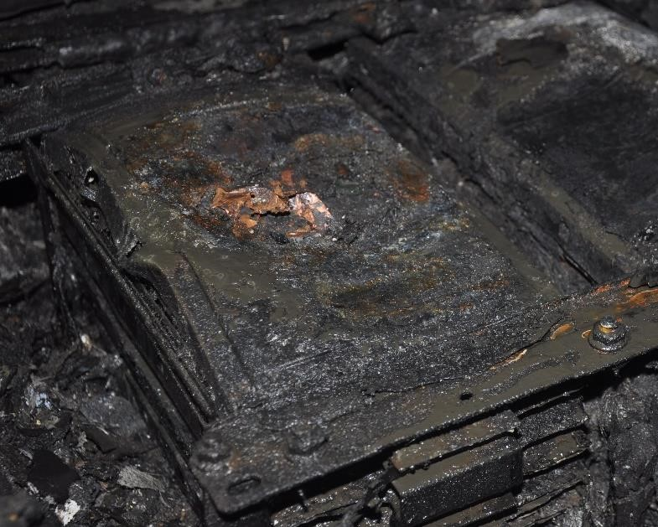

Figure B4.21 Hole in the top of the case
Another cause that may cause the metal to have melted is the creation of a circuit within the battery pack. This circuit could have been caused by the insulators between the different parts of the battery units melting or burning. A test with accu's in which a spanner is placed in the circuit has shown that the metal does not heat up locally, but over almost the entire length of the spanner. Although the fusions found in the battery pack do not seem to have been disturbed bythis, it cannot be ruled out that a circuit has formed outside the battery units in the battery pack.

Getting the battery pack involved in the car fire
Because the police have arrested a suspect for the fire on the basis of the images from the surveillance cameras, it is very likely that the fire did not originate at or in the battery pack. In the end, the battery pack was involved in the fire. This may have happened in different ways.
- There is an open connection between the inside of the battery pack and the car. The plastic joints were burned away by the fire. Burning material may have fallen into the battery pack.
- The outside of the battery pack is made of metal. This metal sits against the metal of the bodywork. By conducting the heat of the fire in the car, the temperature in the battery pack may have become so high that a thermal runaway has arisen in a pouch cell.
- There has been direct flame contact on the outside of the battery pack under the car. This has caused the temperature in the battery pack to become so high that a thermal runaway has arisen in a pouch cell.

Whenthe battery pack is air-cooled, there is an open connection with the car itself. Through the openings in the top of the battery pack, the energy from the fire in the battery pack contributes to the fire capacity of the car fire.

In thephoto below, it is visible within the yellow marking that the metal is discolored. This may have happened by burning the metal bare or by damage as a result of the released combustion products. The edges in the bottom of the car for the ventilatingopenings of the battery pack were hardly damaged by the fire.

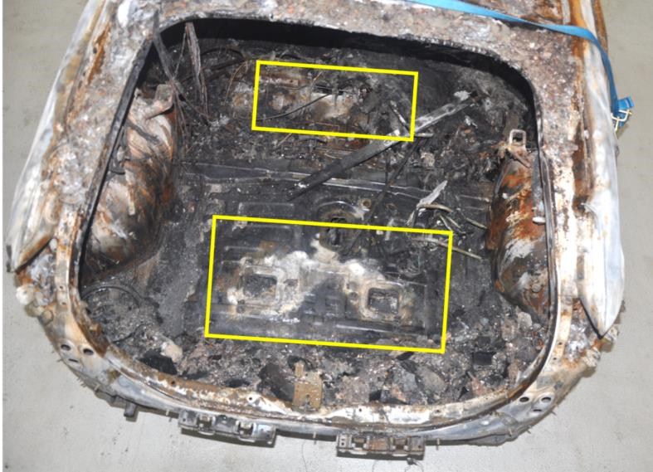
Figure B4.22 Location of the open connection between the battery pack and the car

Annex 5 The questions of the Working Group on Security of the National Agenda

Laadinfrastructuur

This appendix contains the questions asked by the Safety Working Group of the National Agenda for Charging Infrastructure (NAL) following the fire in the Singel garage in Alkmaar on 1 July 2020. The answers to these questions are also given.

- What was the cause (battery in the car, charging infrastructure or arson) (video images) The probable cause is arson. The police have arrested a suspect for this.

- Schade to building due to released energy (heat)
Two vehicles burned. One of them was an electric vehicle. Above both vehicles, damage was caused to the overlying concrete structure. Above the electric vehicle, a larger area of concrete has been affected by the fire than above the conventional vehicle.

- How many batteries in the electric cars eventually burned down. (due to transhipment and heat from the outside)?
The entire battery pack of the electric vehiclewas involved in the fire. It could not be determined how this happened. This may have taken place through the existing connection (ventilation openings) between the inside of the vehicle and the battery pack or as a result of heat beingjellies.

- How were the e-cars positioned in relation to each other and other vehicles? The electric vehicle involved in the fire was completely free. No other vehicles were present in the immediate vicinity. The nearest vehicles were about 10 meters away. In addition to the conventional vehicle that was on fire, there was an electric vehicle just under four meters away. This vehicle has only suffered soot damage and is therefore not involved in the fire.

- How many cars were parked on how many^{m2}?
There were 153 parked vehicles on 8,766 m². The parking garage can accommodate a total of 396 cars.

- Is there a sprinkler system, and if so has it had the intended effect (video images)?
There was no sprinkler system.

- Is there mechanicalextraction, and if so what was the effect?
The parking garage is equipped with user ventilation. This installation is not designed to (continue to) function during a fire. The supply of fresh air is cut off in the event of a fire by closing thedoors. There was no visibility at all during the fight against the fire. Not even when using a thermal imager.

- Are there fire doors (compartments) and has that worked?
At the location of the ramps that give access to the parkinglayers are fire-resistant sliding doors. These were closed on arrival of the fire brigade and have contributed to the fact that there has been hardly any smoke spread to the upper parking layer. The fire-resistant sliding doors are not affected by the brand. The burning vehicles were not in the vicinity of these doors. By closing the doors, the supply of fresh air has stopped. Whether this played a significant role in this case is not clear. The fact that only one vehicle burned at two different locations and more than 11,000 m³ of air was available, provided sufficient oxygen.

- Has smoke been analyzed and what are the findings?
There has been no analysis of the smoke released by the fire. This is not standard with the fire department. In the city centre of Alkmaar, reconnaissance units of the fire brigadecarried out measurements of CO. No CO was measured.

- Has a fire signalling system worked?
The fire alarm system did not detect a fire on parking layer -2 where the vehicles were on fire.

- Does the garage meet the requirements for escape?
From any point in the parking garage, an (emergency) exit can be reached within a walking distance of 40 meters. This meets the level for the existing building.

- If the extinguishing robot is only used after hours of fire, hasn't there been a fire for so long that there is no fuel left?
Yes, the extinguishing robots were only deployed after the fire was extinguished. The fact that there were no cars in the immediate vicinity of the burning vehicles contributed to thefact that there was no longer a fire. Haaglanden's extinguishing robot has supported ventilation.

- If there are photo or video images of the situation before the IONIQ was removed, we would like to see why the TESLA that was supposedly there didnot catch fire.
The Hyundai Ioniq was not parked next to the Tesla. The burning vehicle next to the Tesla was a conventionally powered Citroen C3. The Tesla and Citroen were about four meters apart, withno bars/cars in between. No statement can be made about the amount of heat radiation that the Tesla has received from the smoke layer and directly from the burning vehicle itself. It is unknown how the fire course has been in the vehicle and how quickly the build-up of the smoke layer has taken place. When burning plastics, many of which are present in a vehicle, a lot of smoke is created with soot particles. These soot particles may have shielded the receiving vehicle frombeaming, and a fan hangs in the vicinity of the two vehicles. If this fan, as shown in Figure, has been in operation during the fire, it will have caused an airflow along the unburned vehicle (the Tesla) andthe burning vehicle (the Citroen C3).

To illustrate, below is a photo of the burnt-out Citroen C3 next to the Tesla (left) and one of the Hyundai Ioniq (right) (Image B5.1).
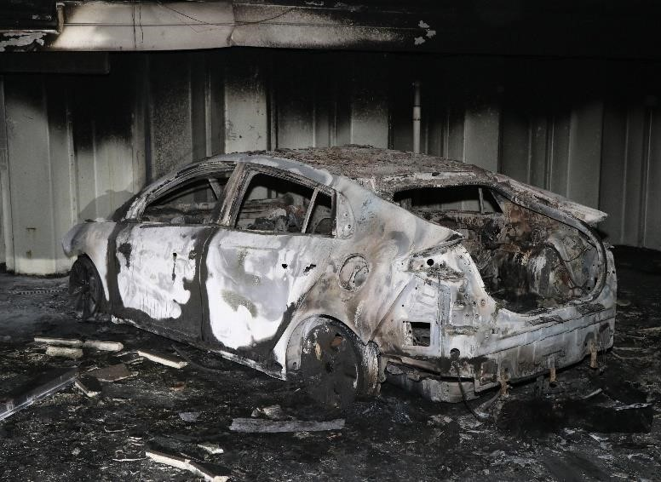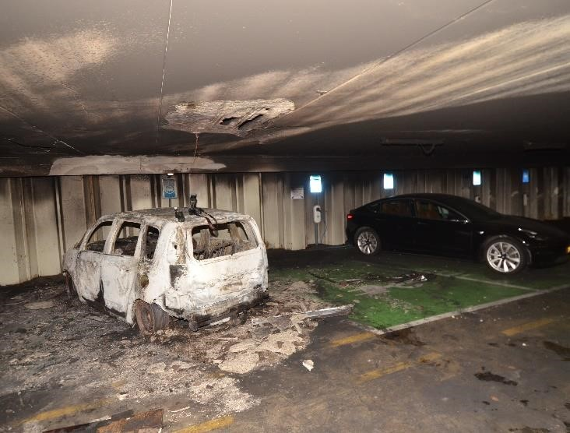
Image B5.1 The burnt-out Citroen C3 and the Hyundai Ioniq
- Do all other electric cars in the garage at level -2 also pose a potential hazard and, in the opinion of the fire brigade, should they also be submerged to prevent battery fires from occurring?
The other electric and non-electric vehicles are only exposed to smoke with a limited temperature. The battery packs of the electric vehicles were therefore not exposed to such a temperature thata thermal runaway could occur. There was no risk that these vehicles would ignite as a result of the fire itself. Therefore, they do not need to be submerged.

- Are these vehicles being assessed by the representatives of thevehicle manufacturers to report on the condition of the battery now that they have been exposed to so much heat?
No, the battery packs of these vehicles have not been exposed to heat to such an extent that they may have suffered damage.

- Inretrospect, was it necessary to immerse the EV in the submersible container?
Yes, measurements by the Hazardous Substances Advisor of the fire brigade showed that the battery pack remained warm after extinguishing the fire. It was then decided that the vehicle was placed under thedupes. Even after the Hyundai was removed from the parking garage, another measurement was carried out which showed that the battery pack still radiated heat.

Appendix 6 Inspection process and responses

A draft version of this report was submitted to the gemeente Alkmaar on 24 September
2020. The intended publication date was set at 1 October 2020. The contact person of the municipality was Mr. L. van Assema, project manager unit PPI. The purpose of this inspection by the municipality was twofold:to know the report so that the municipality could adjust its communication strategy accordingly and to indicate whether there were factual inaccuracies in the report. On 28 September, the municipality of Alkmaar responded to the report.

Then , on 30 September, due to administrative changes, the municipality asked for more time, so that the deputy mayor could read in and prepare himself. The IFV agreed to this request and the publication date was postponed to 14 October. In addition, theIFV indicated that the report was now final and that this version would be published on 14 October.
On 13 October, acting mayor of Alkmaar, Mr. Roemer, because of his new recent role, asked the IFV to postpone thereport for a week to read and prepare. The acting mayor has indicated that he will respect the independence of the IFV and its lecturers. The IFV has again agreed to this request for postponement of publication.

The response received on 28 September can be divided into:
- Corrections of factual inaccuracies and additions at the level of detail.
These have been copied – insofar as correct and relevant – and the relevant reporting text has been adapted accordingly.
- Additions and text suggestions that have not been adopted.
Text suggestions that did not concern factual inaccuracies have generally not been taken up. The most important additions according to the municipality are included in this appendix and provided with a justification or explanation from the researchers.

Themunicipality also proposed changes on 1 October. In accordance with the agreements made, these have no longer been processed. For the sake of completeness, these are listed below.

Comments/additions municipality | Reaction IFV
"As an attachment, the permits of the original building plan have been sent." | The documents have been studied and, where necessary, the report has been adjusted.
"With regard to the notification, I have understood from Valet Parking Service that the notification from the BMI hasbeen 'turned off' at the request of the brandweer. This is connected to the SMC." | Not taken over.  Upon enquiry, the NHN safety region indicates that there is a direct notification.
"After sending the draft, it is unclear who did that. It requested camera images." IFV already has the camera images in a
early stage requested via the
safety region. The safety region has indicated that these camera images have been destroyed in accordance with a standard procedure of the parking garage. As a result, the IFV could not analyse camera images. Even after the e-mail of 28 September from the municipality , the IFV was not allowed to receive any images.
Extra in the mail of 12 October: Not processed because it
"the fire resistance of the garage with regard to information has already been processed at the collapse of the construction could not be studied of the buildingpermit and
formatted, while this data was only provided after the date until which a response could be made. was possible, has been provided.
The builder of the main supporting structure has recorded the fire resistance. The attached study (https://we.tl/t6IMJdlHiBm ) shows that:
- the Steel sheet piling construction: The report describes in section 8.3 (sheet 8.2) that a fire resistance requirement of 60 minutes applies to the sheet piling construction;
- the Concrete Structure: In the report it is described in section 9.2 (sheet 9.3) that a fire resistance requirement of 60 minutes applies to the
betonconstructie.”

https://www.ifv.nl/kennisplein/Documents/201408-brand-in-parkeergarages.pdf.
See, among other things, dand Answering questions from Members Beckerman and Laçin (both SP) about fire danger in parking garages and under homes en Major concerns hoas about garage safety.
The Safety Working Group of the National Charging Infrastructure Agenda (NAL) offerssupport in the field of physical and digital security with factsheets and other knowledge products. The working group consists of various parties from government, municipalities, network operators, market, knowledge institutions and branch organizations.
With a view on the influence that these facilities have had on the development of fire course and incident response. This research question is therefore not focused on whether or not it complies with laws and regulations.
For clarification: in chapter ofar the intervention characteristics are not referred to the tanker sprayers with their call number during the incident, but to their origin. The reason for this is that during the incident units changed call numbers, which in the description up to verwarring would lead.
Bagviewer.kadaster.nl.
Valet parking is an independent organization that operates and manages the parking garage on behalf of the municipality of Alkmaar.
These indicators are discussed in more detail in Annex 4.
On base of an area of 4383 m² with a free height of 2.55 meters on parking layer -2.
In view of the influence that these facilities have had on the development of fire course and incident response. This research question is just that.e not aimed at whether or not to comply with laws and regulations.
This means that the building is entered and that the fire room is always approached from a safe space. In this case, level -2 was approached from a safe and smoke-free staircasepenhuis, albeit that in this case in fact waiting for the fire to be extinguished was the most important step.
https://www.youtube.com/watch?v=tMUBBAiFX6c.
With the new generation of water-cooled battery packs, this is not the case more the case.

